**WinAPI in ASM**

WINAPI IN ASSEMBLY INTRODUCTION 2

DISPLAYING A MESSAGEBOX 18

CONSOLE INPUT 25

CHECKING FOR ERRORS 26

SINGLE CHARACTER INPUT 27

CONSOLE OUTPUT 34

FILE HANDLING 40

WRITEFILE AND SETFILEPOINTER 45

CONSOLE WINDOW MANIPULATION 52

SETTING TEXT COLOR 60

TIME, WINAPI AND ASSEMBLY 63

CALLING 64-BIT WINAPI FUNCTION IN MASM 72

DYNAMIC MEMORY 76

x86 MEMORY MANAGEMENT 81

WINAPI IN ASSEMBLY INTRODUCTION

When a Windows application starts up, it can launch in one of two ways:  
either as a **console application** or as a **graphical (windowed) application**.

In our project files, we tell the linker that we want a console-based program by using this option with the LINK command:

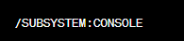

A console program looks a lot like the old MS-DOS window—but with some modern upgrades we’ll get into soon.

Under the hood, the console includes:

**One input buffer**, which stores input records. These records describe things like:

* Keyboard input
* Mouse clicks
* User actions such as resizing the console window

**One or more screen buffers**, which are two-dimensional arrays holding:

* Character data
* Color and attribute information

These screen buffers control how text actually appears inside the console window.

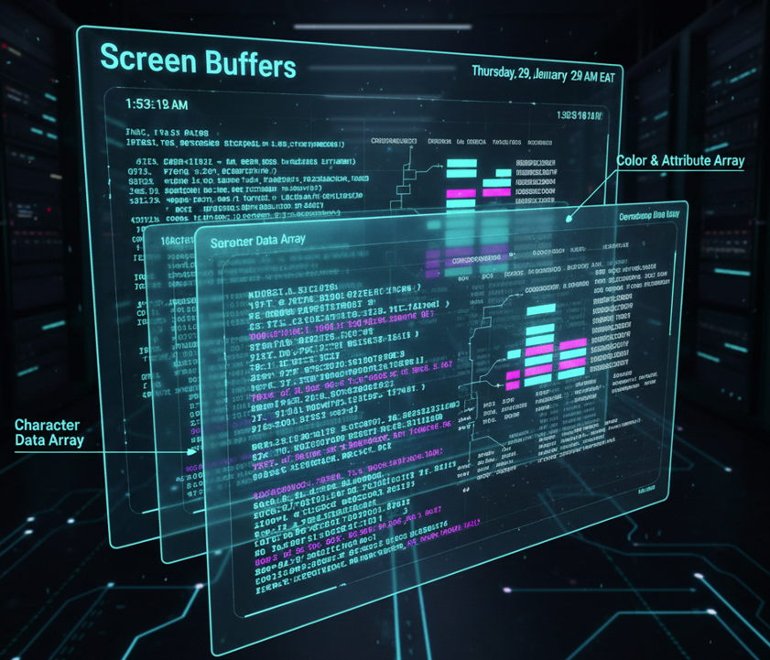

Reference Material (a.k.a. where the real answers live)

* I’ve put Win32 API reference info in **my own GitHub repository**.  
  If you don’t see it, just email me and I’ll send you a ZIP file.
* **Charles Petzold’s book** is another classic reference.  
  Fair warning: it’s old-school—huge, technical, no colors, no hand-holding.  
  If you enjoy reading 1000-page technical manuals without falling asleep, it’s for you.  
  If you want the physical book… well, more power to you—go buy it 😄

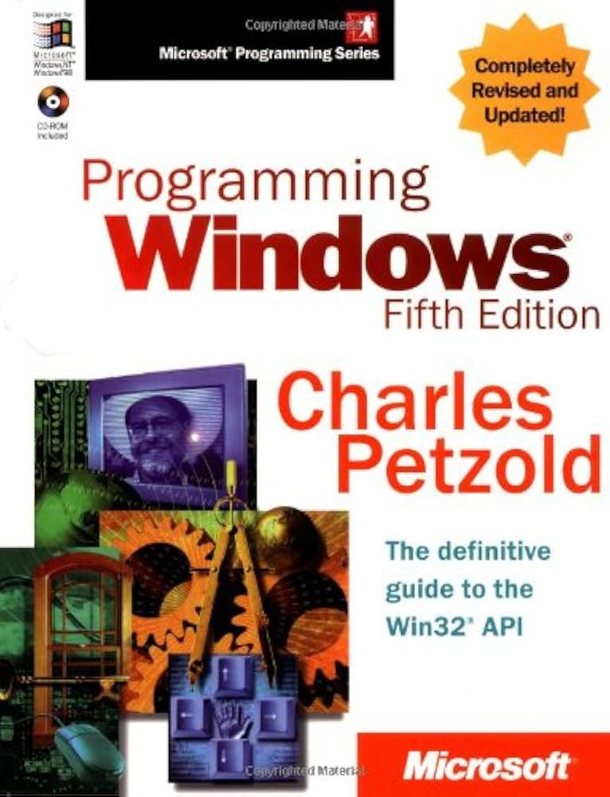

Key Takeaways from This Section

* This section introduces **a small subset of Win32 API functions**, using simple examples.  
  It’s meant as a starting point, not a complete reference.
* For full documentation, the **Microsoft MSDN website** is the authoritative source.  
  When searching, make sure to filter for **“Platform SDK.”**
* The sample programs include lists of function names found in:
  + kernel32.lib
  + user32.lib  
    These are provided mainly for reference.
* Win32 API functions often rely on **named constants**, such as:

In Microsoft’s MSDN Library documentation, the trailing **“A”** or **“W”** is typically omitted from function names.

In the program include files provided with this book, functions such as WriteConsoleA are redefined as follows:

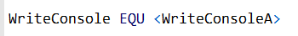

This definition allows you to call WriteConsole using a generic function name, without explicitly specifying the character set.

There are two levels of console access, each balancing ease of use and control:

High-Level Console Functions

* Read a stream of characters from the console’s input buffer.
* Write character data to the console’s screen buffer.
* Support input and output redirection to and from text files.
* Simpler to use, but offer less control over console behavior.

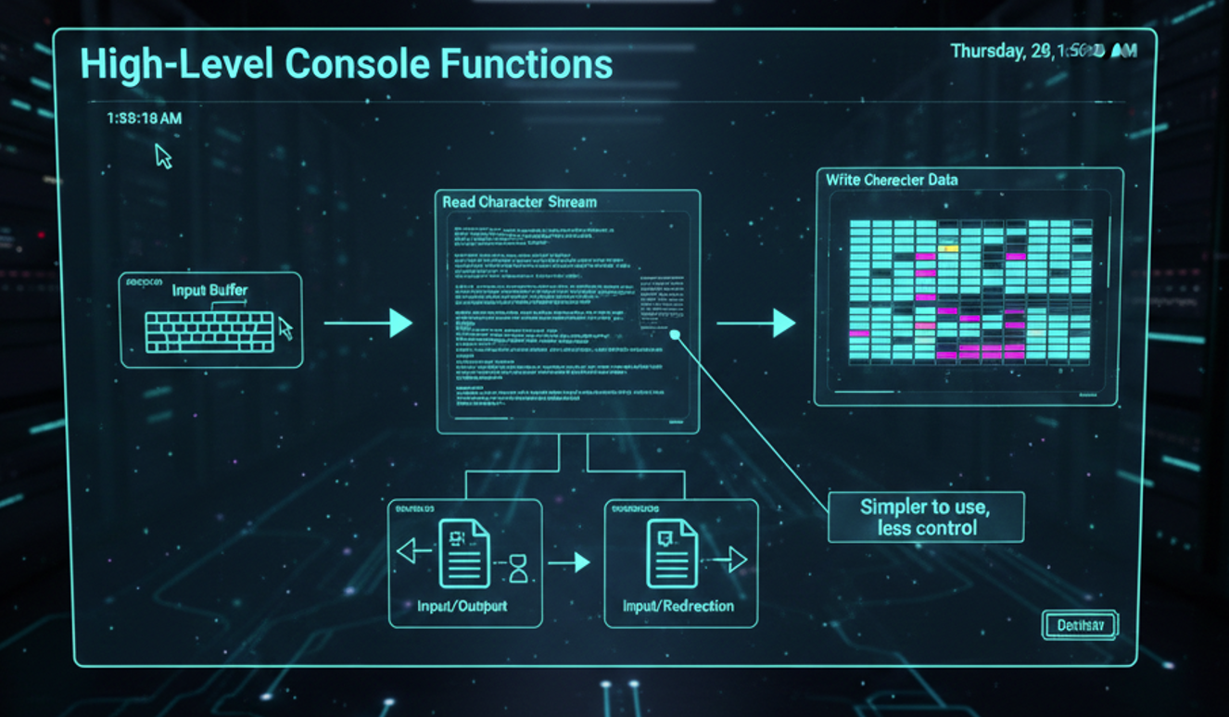

Low-Level Console Functions

* Provide detailed information about keyboard and mouse events.
* Capture user interactions with the console window (such as dragging and resizing).
* Allow precise control over the console window’s size, position, and text colors.
* More complex, but offer full control over console operations.

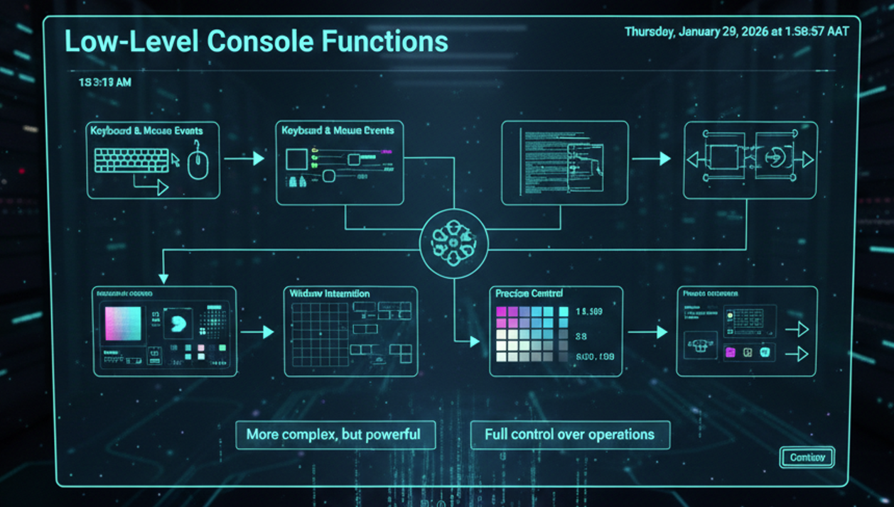

Windows Data Types

MASM provides its own versions of the standard MS-Windows data types. The mappings are pretty straightforward, once you see how they line up.

**MASM ↔ Windows Type Mappings**

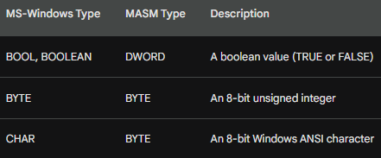

In other words, these MASM types are effectively equivalent to their Windows counterparts:

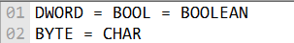

So, if you see a Windows function expecting a BOOL, using a DWORD in MASM is perfectly correct.

A Note About HANDLEs (Important!)

One thing that often surprises people:  
the Windows HANDLE type is **also just a DWORD**.

That means a single HANDLE variable can store a reference to many different kinds of objects, such as:

* A window
* A file
* A memory region
* Other system objects

The meaning of the handle depends entirely on **which API function returned it**—not on the data type itself.

Here is an example of how to declare and use a HANDLE variable in MASM:

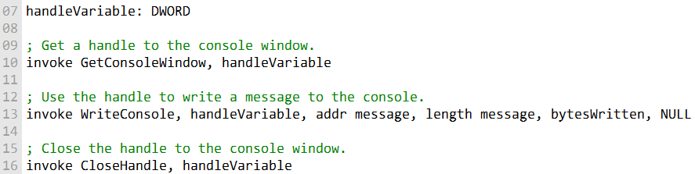

The **SmallWin.inc** include file contains constant definitions, text equates, and function prototypes used in Win32 API programming.

It is automatically included in programs through **Irvine32.inc**.

The file defines several Win32 data types, including the **HANDLE** type.

Below are examples demonstrating how to use the **SmallWin.inc** include file:

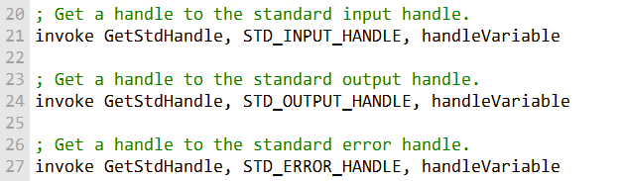

SmallWin.inc and Win32 Data Types (MASM-Friendly Overview)

The SmallWin.inc include file exists to make **Win32 API programming in MASM less painful**.  
It defines common Windows data types, structures, constants, and function prototypes so you don’t have to reinvent the wheel every time.

It’s automatically included when you use Irvine32.inc, so in most MASM projects, you already have access to it.

I. Common Windows Data Types

Here’s what the most common Win32 data types actually mean, without the legalese:

* **BOOL / BOOLEAN**  
  A simple true-or-false value.
* **BYTE**  
  An 8-bit unsigned integer (0–255).
* **CHAR**  
  An 8-bit Windows ANSI character.  
  This is what older (non-Unicode) Windows programs use for text. The exact character set depends on language and region.
* **DWORD**  
  A 32-bit unsigned integer (0–4,294,967,295).
* **WORD**  
  A 16-bit unsigned integer (0–65,535).
* **INT / LONG**  
  A 32-bit signed integer  
  (−2,147,483,648 to +2,147,483,647).  
  INT and LONG are the same size in Win32.
* **UINT**  
  A 32-bit unsigned integer, functionally the same as DWORD.

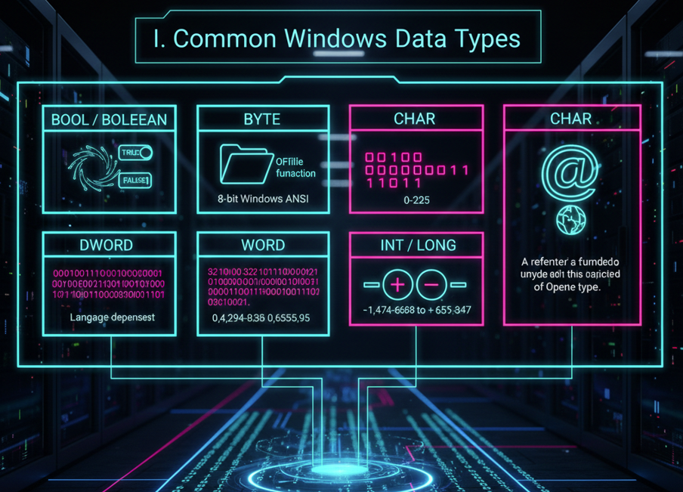

II. Handles and Pointer Types

* **HANDLE**  
  A reference to a Windows object (window, file, memory region, etc.).  
  Internally, it’s just a 32-bit value, but *what it refers to* depends on how you got it.
* **HFILE**  
  A handle returned by the OpenFile function.
* **LPVOID**  
  A pointer to *anything* (unspecified type).
* **LPCVOID**  
  A pointer to constant data of any type.

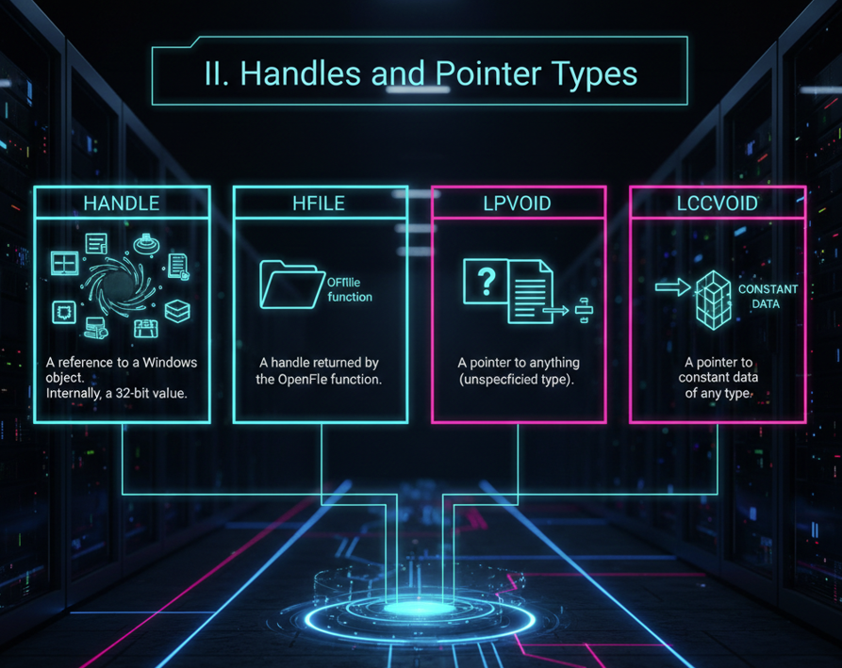

III. String and Text Pointer Types

These show up everywhere in the Windows API:

**LPSTR** - Pointer to a null-terminated ANSI string.

**LPCSTR -** Pointer to a constant null-terminated ANSI string.

**LPTSTR -** Pointer to a character string that works with both ANSI and Unicode builds.

**LPCTSTR** - Pointer to a constant string that’s portable across ANSI, Unicode, and double-byte character sets (used in languages like Chinese and Japanese).

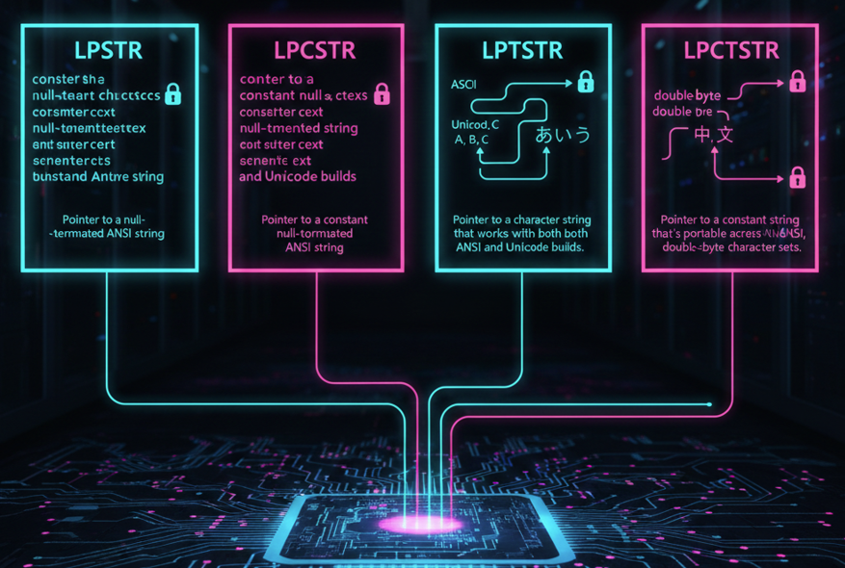

IV. Message and Callback Types

* **WPARAM**  
  A 32-bit value passed to a window procedure.  
  Usually contains message-related info.
* **LPARAM**  
  Another message parameter.  
  Often used to store pointers to structures or other data.
* **LRESULT**  
  A 32-bit value returned by a window procedure or callback.
* **WNDPROC**  
  A pointer to a window procedure function (the function that processes window messages).

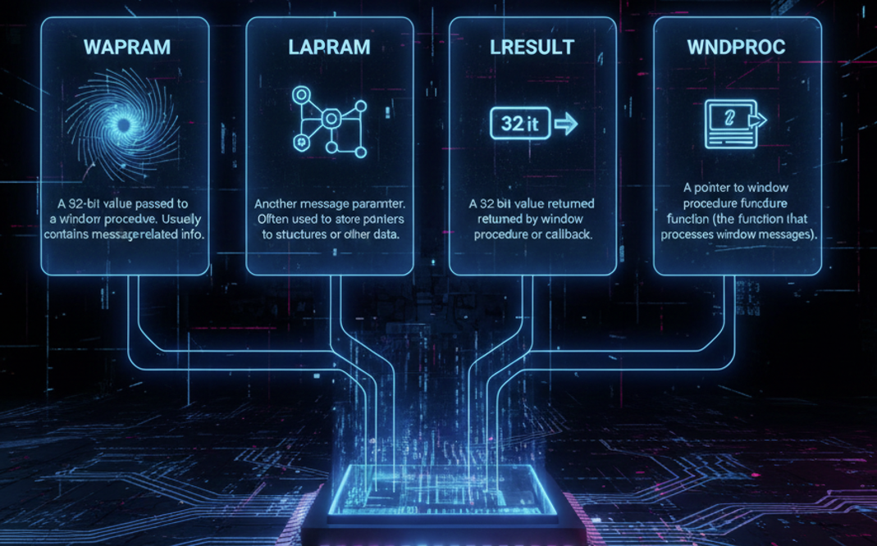

Special Structures

I. COORD Structure

Used to store a position in the console window.

* X – horizontal coordinate
* Y – vertical coordinate

Both values are WORDs.

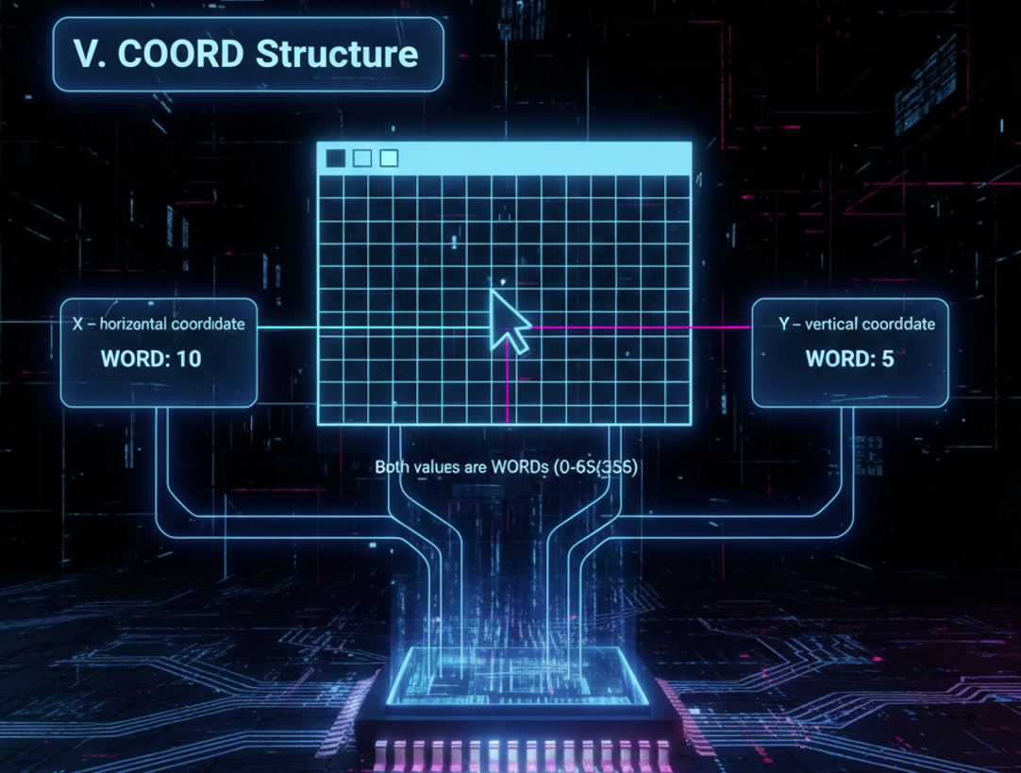

II. SYSTEMTIME Structure

Stores detailed date and time information:

* wYear – year
* wMonth – month
* wDayOfWeek – day of the week
* wDay – day of the month
* wHour – hour
* wMinute – minute
* wSecond – second
* wMilliseconds – milliseconds

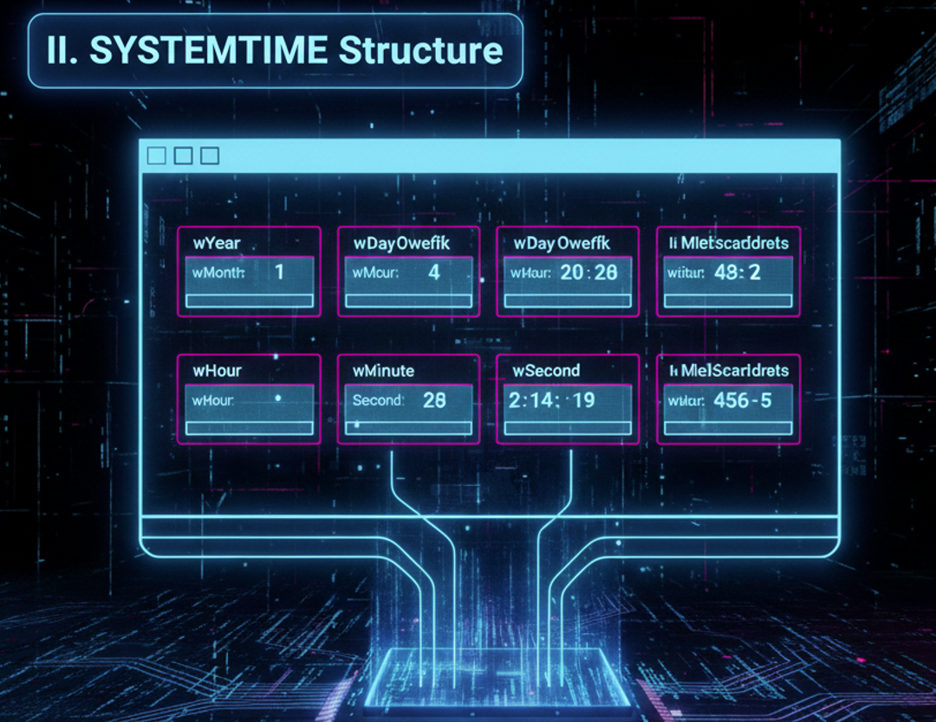

Console Handles (The Backbone of Console I/O)

Console handles are **32-bit values** that identify console devices.  
Win32 console functions use these handles to perform input and output.

**The Three Standard Console Handles**

* **STD_INPUT_HANDLE** – keyboard input
* **STD_OUTPUT_HANDLE** – console display output
* **STD_ERROR_HANDLE** – error message output

You retrieve these using: **GetStdHandle**

Once you have a handle, you can use it to read input, write output, or control the console’s behavior.

Common Console I/O Functions

I. Input and Output

* **ReadConsole** – reads keyboard input
* **ReadConsoleInput** – reads keyboard, mouse, and other events
* **WriteConsole** – writes text to the console (most commonly used)

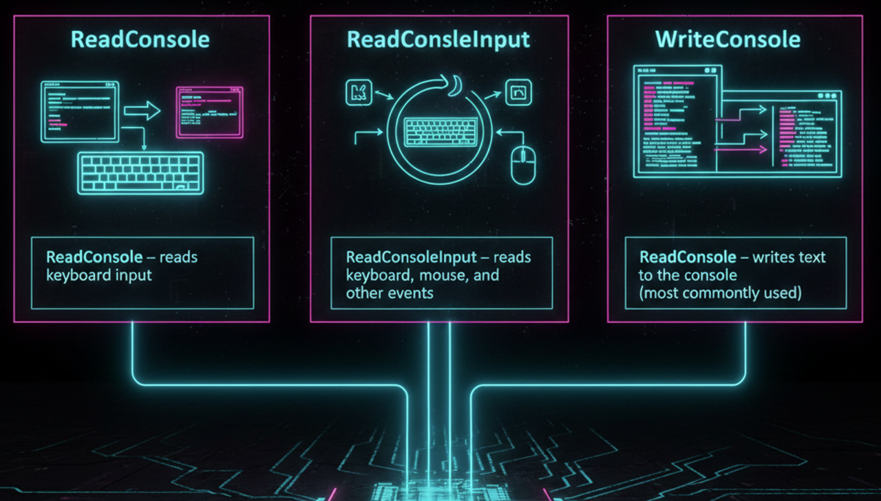

II. Screen Buffer Access

* **CreateConsoleScreenBuffer** – creates a new screen buffer
* **SetConsoleActiveScreenBuffer** – switches which buffer is visible
* **ReadConsoleOutput** – reads characters and colors from the screen
* **WriteConsoleOutput** – writes characters and colors to the screen

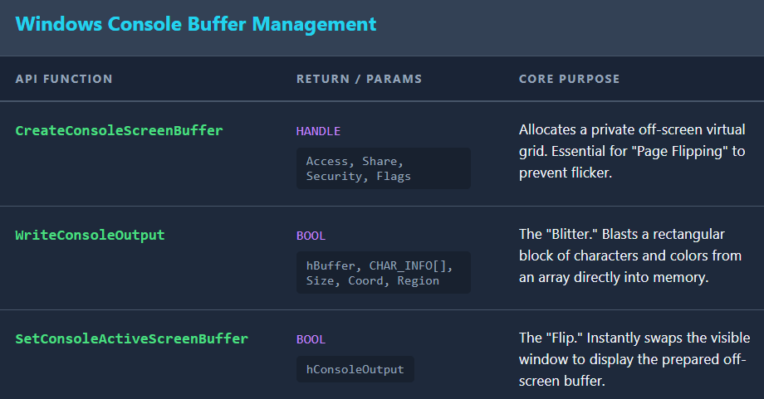

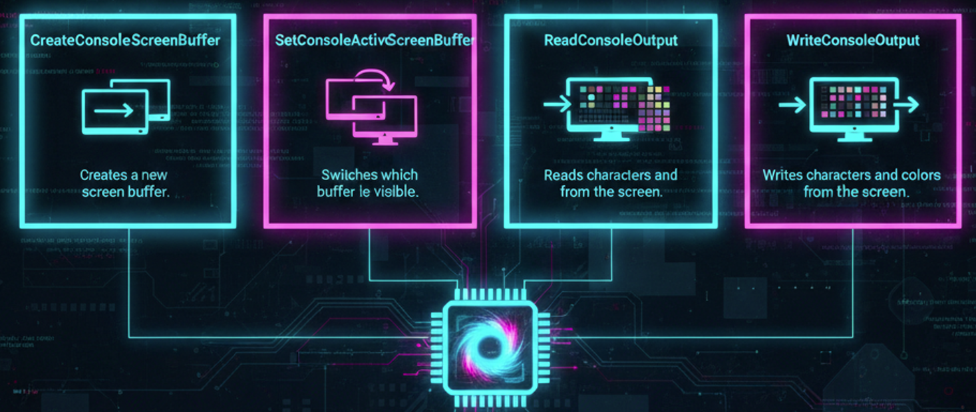

III. Console Appearance and Behavior

* **SetConsoleTextAttribute** – changes text and background colors
* **FillConsoleOutputCharacter** – fills an area with a character
* **FillConsoleOutputAttribute** – fills an area with color attributes
* **SetConsoleCursorPosition** – moves the cursor
* **SetConsoleCursorInfo** – controls cursor size and visibility
* **SetConsoleWindowInfo** – resizes or moves the console window
* **SetConsoleTitle** – sets the console window title

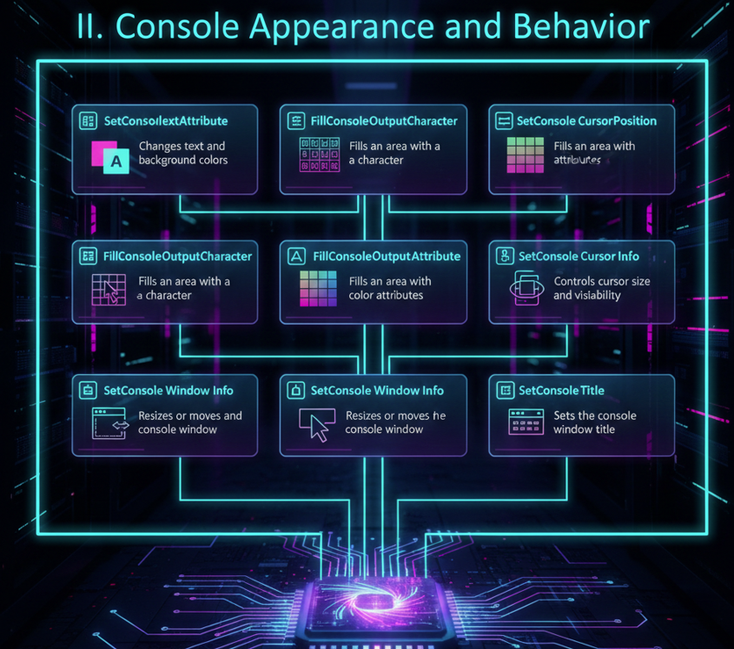

IV. Console Modes and Code Pages

* **GetConsoleMode / SetConsoleMode** – control input/output behavior
* **GetConsoleCP / SetConsoleCP** – get or set input code page
* **GetConsoleOutputCP / SetConsoleOutputCP** – get or set output code page

These are especially important for international character support.

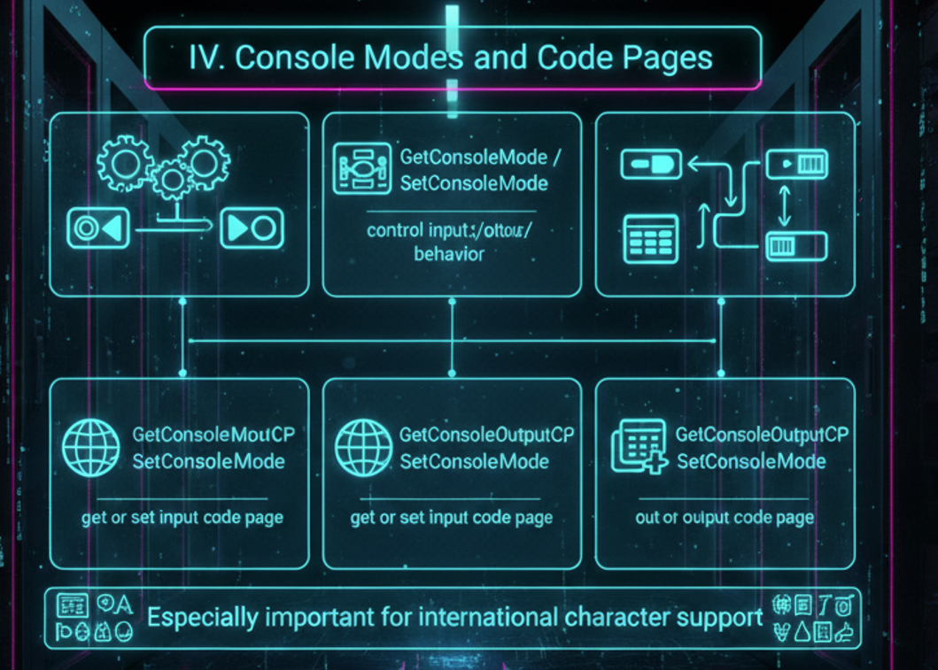

V. Console Management and Control

* **AllocConsole** – creates a new console
* **FreeConsole** – detaches from the console
* **FlushConsoleInputBuffer** – clears unread keyboard input
* **GetConsoleWindow** – retrieves the console’s window handle
* **GetConsoleTitle** – retrieves the current console title
* **GetLargestConsoleWindowSize** – maximum possible console size

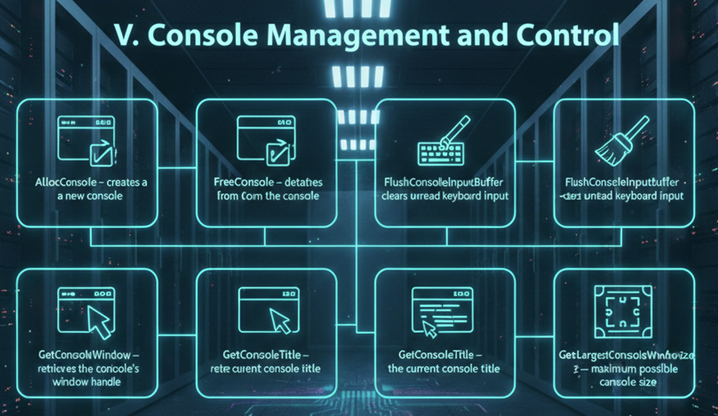

VI. Console Events and Signals

* **SetConsoleCtrlHandler** – registers a handler function
* **HandlerRoutine** – your custom handler function
* **GenerateConsoleCtrlEvent** – sends control signals (close, terminate, etc.)

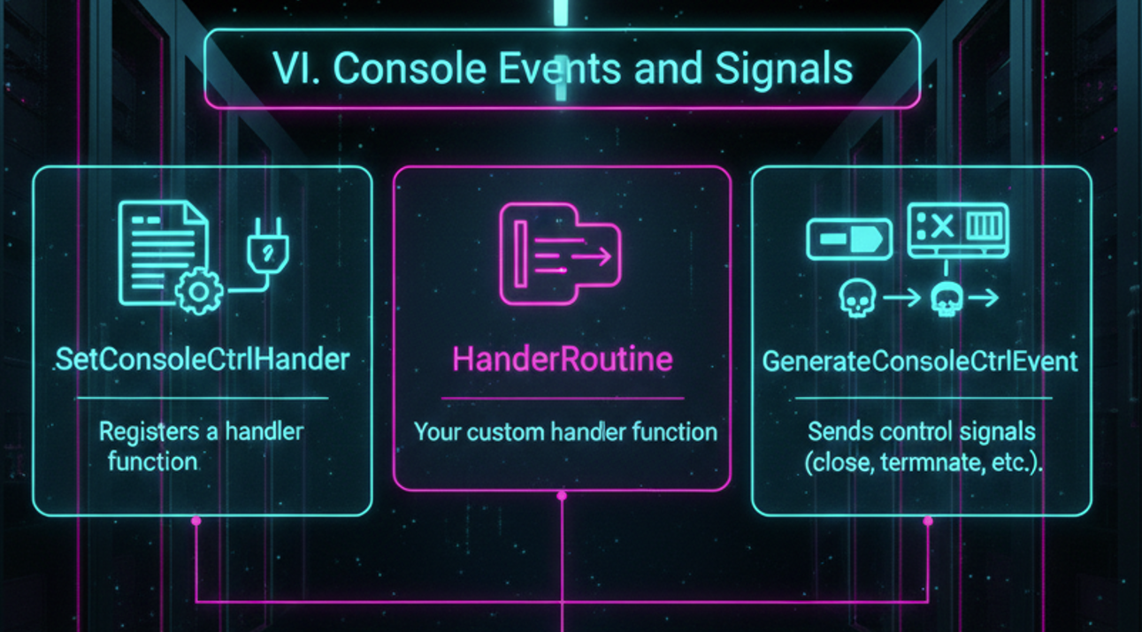

VII. Why This Matters

Console handles and Win32 console functions are **the core of console-based Windows programs**.  
Once you understand how handles, buffers, and modes fit together, you can:

* Build responsive console apps
* Control text layout and color
* Handle keyboard and mouse input
* Manage multiple screen buffers

In short: **this is where simple DOS-style programs turn into real Windows applications.**

DISPLAYING A MESSAGEBOX

In Win32 console applications, you can use the **MessageBoxA** function to display a message box to the user.

The MessageBoxA function requires **four parameters**:

**hWnd**

* A handle to the window that owns the message box.
* If this parameter is NULL, the message box is created as a top-level window.

**lpText**

* A pointer to the text displayed inside the message box.

**lpCaption**

* A pointer to the text displayed in the message box’s title bar.

**uType**

* A bit-mapped integer that specifies the type of message box.
* This parameter controls:
  + The buttons displayed (e.g., OK, Yes/No)
  + The icon displayed
  + The default selected button

The following table lists some of the possible values for the **uType** parameter:

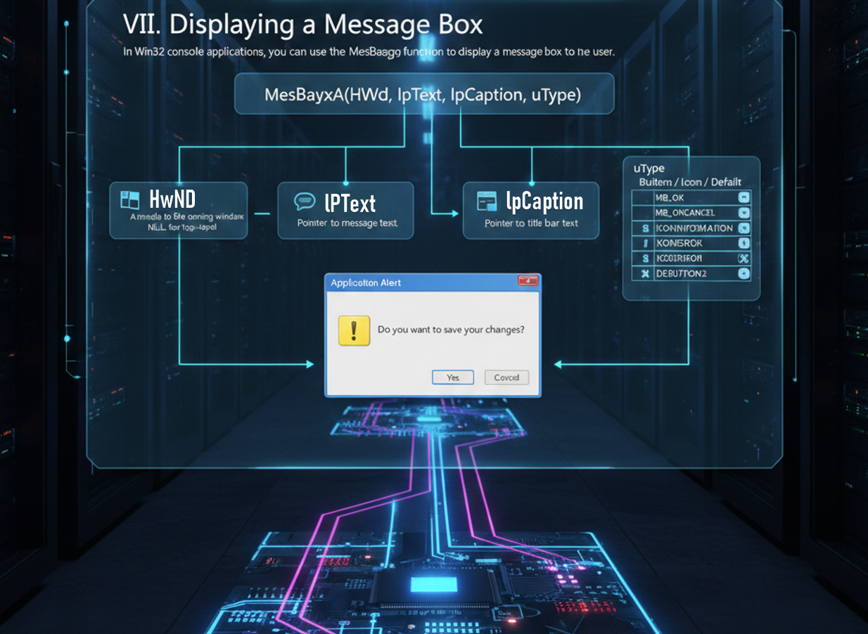

We learnt all this in the Windows API notes.

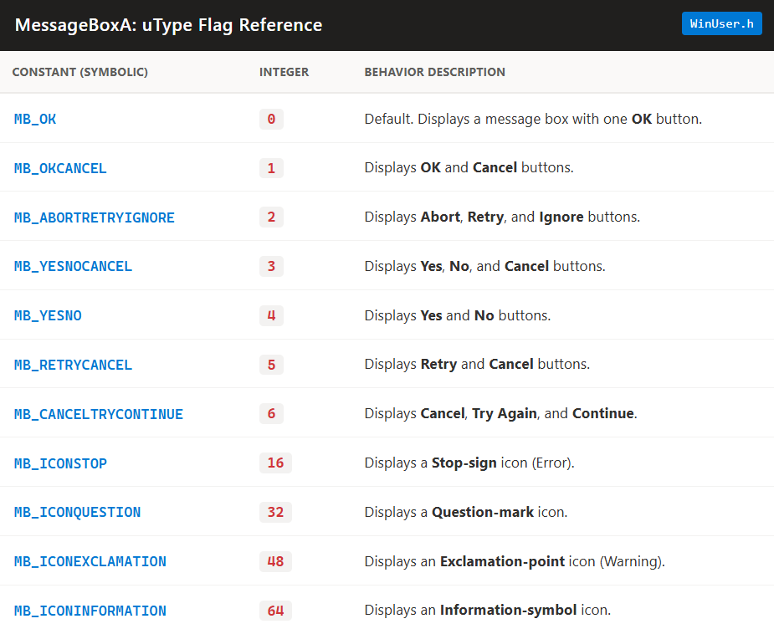

The **values in the table** are commonly used as **integer constants** for the **uType** parameter when creating message boxes.

The **uType** parameter determines the **type and behavior** of the message box.

In your program, you can use these constants like this:

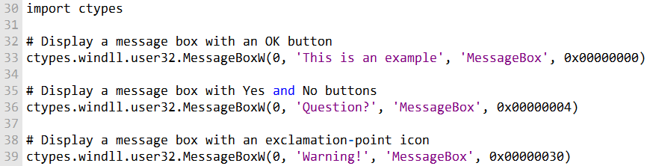

Or

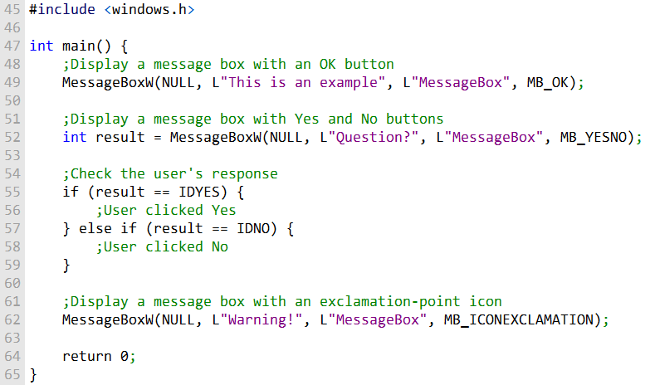

In this C program, different **message box types** are used, including:

* MB_OK – displays a single OK button
* MB_YESNO – displays Yes and No buttons
* MB_ICONEXCLAMATION – displays an exclamation icon

To specify the message box type, pass the corresponding **integer constant** as the **third parameter** to the MessageBoxW function.

The program can **check the user’s response** to the Yes and No buttons by examining the value returned by the function.

* For example, IDYES indicates the user clicked Yes.
* IDNO indicates the user clicked No.

Or

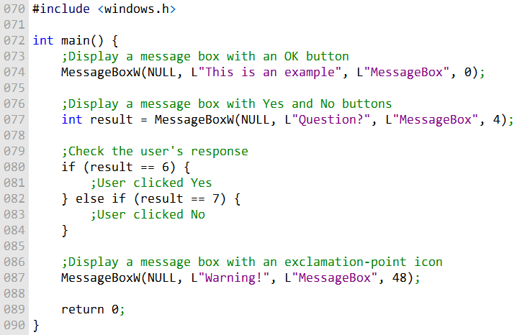

* In this code, **integer values** are used directly to specify message box types.
* Examples of integer values and their corresponding constants:
  + 0 → MB_OK (single OK button)
  + 4 → MB_YESNO (Yes and No buttons)
  + 48 → MB_ICONEXCLAMATION (exclamation icon)
* You can use these values to create message boxes with the **desired type and behavior** in your C program.

Demonstration Program

Program that demonstrates some capabilities of the MessageBoxA function.

The first function call displays a warning message:

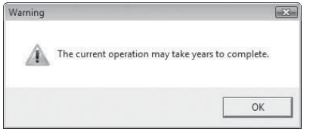

The second function call displays a question icon and Yes/No buttons.

If the user selects the Yes button, the program could use the return value to select a course of action:

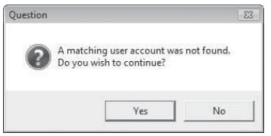

The third function call displays an information icon with three buttons:

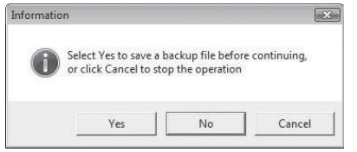

The fourth function call displays a stop icon with an OK button:

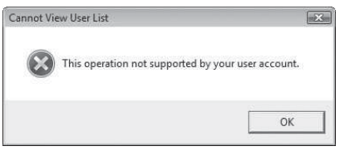

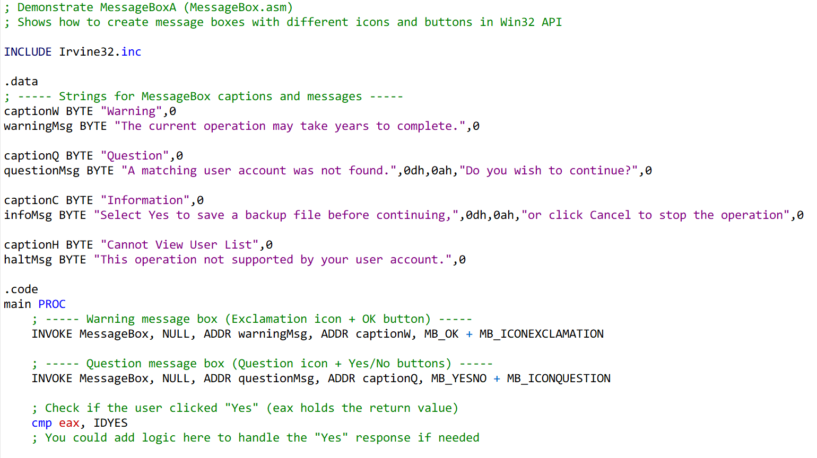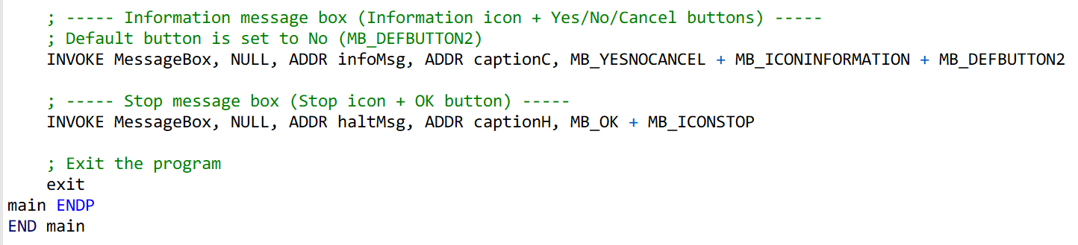

**Includes** Irvine32.inc which provides macros like INVOKE and constants for Win32 API.

**.data section** defines captions and messages for each message box, null-terminated.

**main PROC** is the entry point where all message boxes are displayed:

* MessageBox is called with parameters: hWnd, message, caption, and type (uType).
* uType combines **buttons** + **icons** + optional **default button**.

The **return value in eax** indicates which button the user clicked:

* IDYES → Yes
* IDNO → No
* IDCANCEL → Cancel

After all message boxes are shown, the program exits cleanly.

CONSOLE INPUT

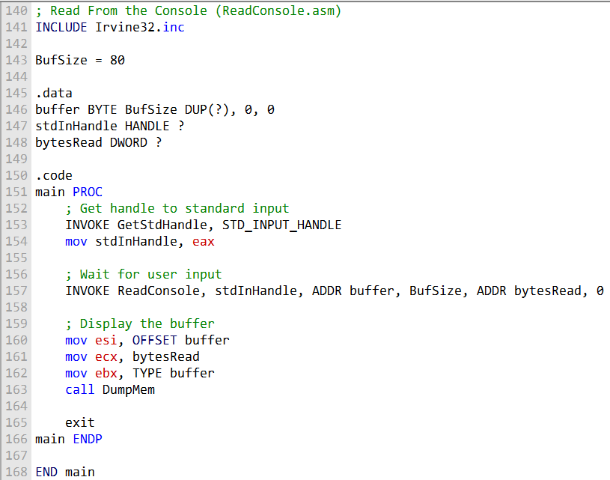

In Win32 console programming, there is a **console input buffer** that stores **input event records** (keystrokes, mouse movements, and mouse clicks).

**High-level input functions**, like ReadConsole, process these events and return a **stream of characters** to the program.

**ReadConsole function**:

* Reads text input from the console and stores it in a buffer.
* Parameters include:
  + Console input handle
  + Pointer to a character buffer
  + Number of characters to read
  + Pointer to store the count of characters read
  + Reserved parameter (must be 0)

Example program workflow:

* Defines **buffer size** (BufSize) and declares necessary data variables:
  + Buffer for storing input
  + Handle for standard input (stdInHandle)
  + Variable for number of bytes read (bytesRead)
* Retrieves **standard input handle** using GetStdHandle.
* Calls **ReadConsole** to read input from the user.
* Parameters include standard input handle, buffer, max characters to read, pointer for characters read, and reserved value 0.

After reading input, the program displays the buffer content using **DumpMem** (from Irvine32 library), showing both **hexadecimal and ASCII representations**.

The program can display **all user input**, including end-of-line characters (0Dh and 0Ah) from pressing Enter.

CHECKING FOR ERRORS

Read the **GetLastError.asm** file, no need to yap😂

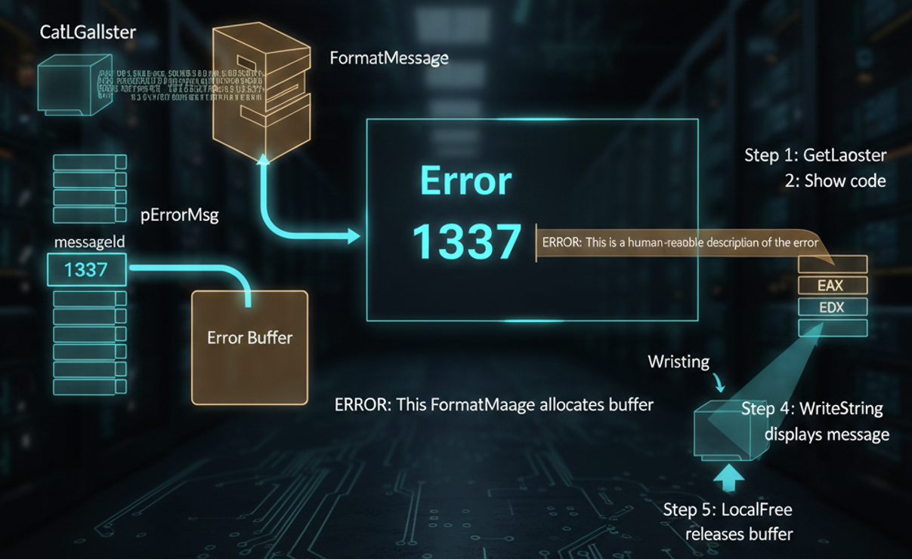

SINGLE CHARACTER INPUT

**Single-Character Input and Irvine32 Keyboard Procedures**

When working in **console mode** on Windows, reading a single character from the keyboard involves a few layers: the keyboard device driver, scan codes, virtual-key codes, and the program’s message queue.

Here’s a breakdown of how it works and how the Irvine32 library helps simplify it.



How Keyboard Input Works in Windows

1. **Key Press**  
   When you press a key, the keyboard device driver sends an **8-bit scan code** to the computer. This code tells the system which physical key was pressed.
2. **Key Release**  
   Releasing the key sends a second scan code.
3. **Translation to Virtual-Key Codes**  
   Windows converts these scan codes into **16-bit virtual-key codes**.  
   Virtual-key codes are **device-independent**, meaning they identify the key’s purpose (like VK_UP for the Up Arrow) rather than its physical location.
4. **Message Queue**  
   Windows creates a message containing the scan code, virtual-key code, and related info.  
   This message is placed in the program’s **message queue**.
5. **Program Access**  
   The console program eventually retrieves the message using the **console input handle**.

Irvine32 Keyboard Procedures

The **Irvine32 library** provides two main procedures to make keyboard input much easier:

ReadChar  
Waits for a key to be typed and returns its ASCII value in the AL register.

ReadKey  
Checks for a keypress **without waiting**.

* If no key is pressed, the **Zero Flag** is set.
* If a key is pressed:
  + Zero Flag is clear
  + AL contains either an ASCII code or zero (for special keys)
  + Upper halves of EAX and EDX are overwritten

Handling Special Keys with ReadKey

* If AL is zero, the key is a **special key** (like a function key or arrow key).
* AH contains the **scan code** for the key.
* DX contains the **virtual-key code**.
* EBX contains **control key state information**.

Control Key State Values in EBX

You can check EBX to see which control keys are active:

* CAPSLOCK_ON – CapsLock is on
* NUMLOCK_ON – NumLock is on
* SCROLLLOCK_ON – Scroll Lock is on
* SHIFT_PRESSED – Shift key is pressed
* LEFT_ALT_PRESSED / RIGHT_ALT_PRESSED – Alt key pressed
* LEFT_CTRL_PRESSED / RIGHT_CTRL_PRESSED – Ctrl key pressed
* ENHANCED_KEY – Key is enhanced (special function)

These constants let you **respond to user actions** precisely.

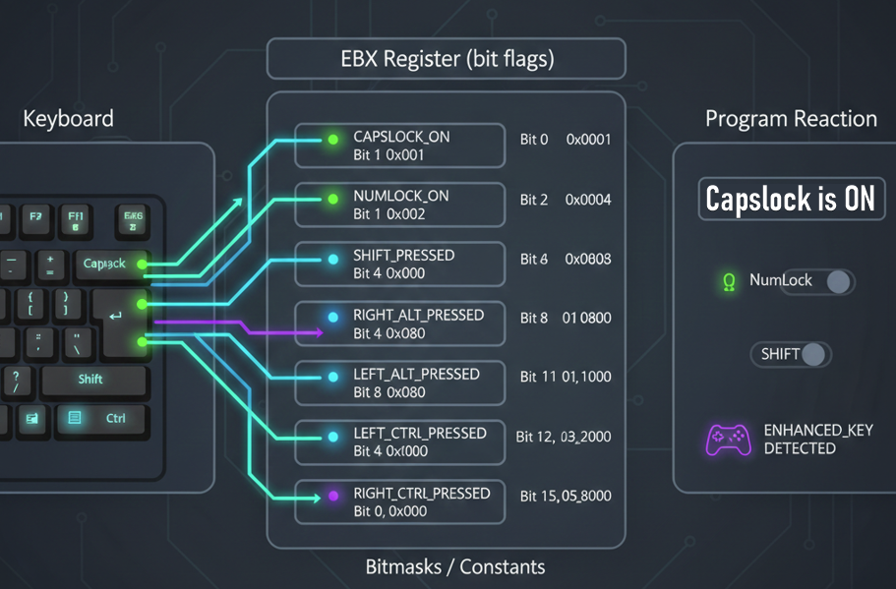

Testing Keyboard Input

Using ReadKey

You can write a simple test program:

1. Call ReadKey (optionally with a delay to allow Windows to process its message loop).
2. If a key is pressed (ReadKey returns non-zero):
   * Check EBX using constants like CAPSLOCK_ON
   * Display whether CapsLock (or other keys) is ON or OFF

This helps verify that your keyboard input handling works correctly.

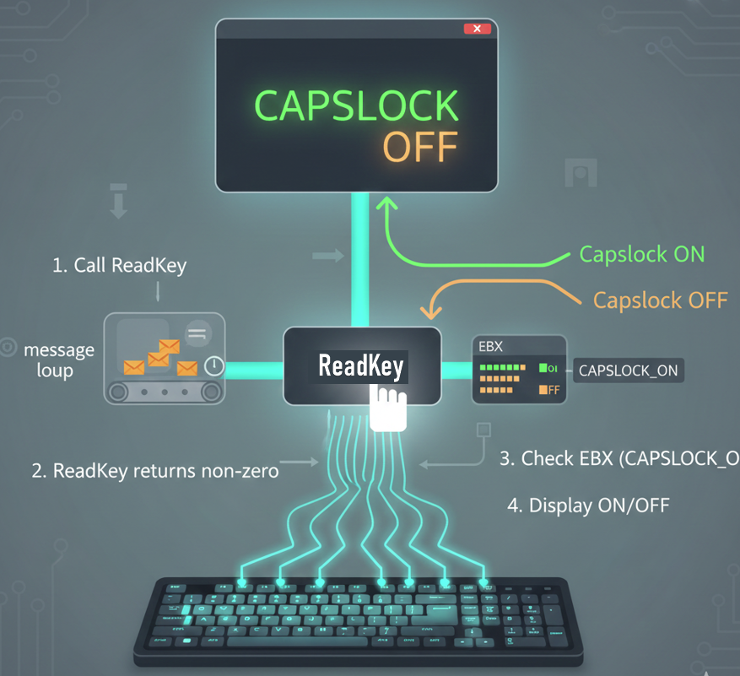

Using GetKeyState

* GetKeyState is a **Win32 API function** that lets you test **the current state of any individual key**.
* Pass it a **virtual-key code** (like VK_CAPITAL for CapsLock or VK_NUMLOCK for NumLock).
* It returns the key’s state (pressed, toggled, etc.) so your program can react accordingly.



Summary

* **ReadChar** → wait for a single ASCII character
* **ReadKey** → check immediately for keypress, including special keys
* **EBX & control key constants** → lets you detect Shift, Ctrl, Alt, CapsLock, and more
* **GetKeyState** → check the state of any key at any time

Using these procedures, your assembly programs can **easily handle single-character input**, detect special keys, and respond to the state of control keys in real time.

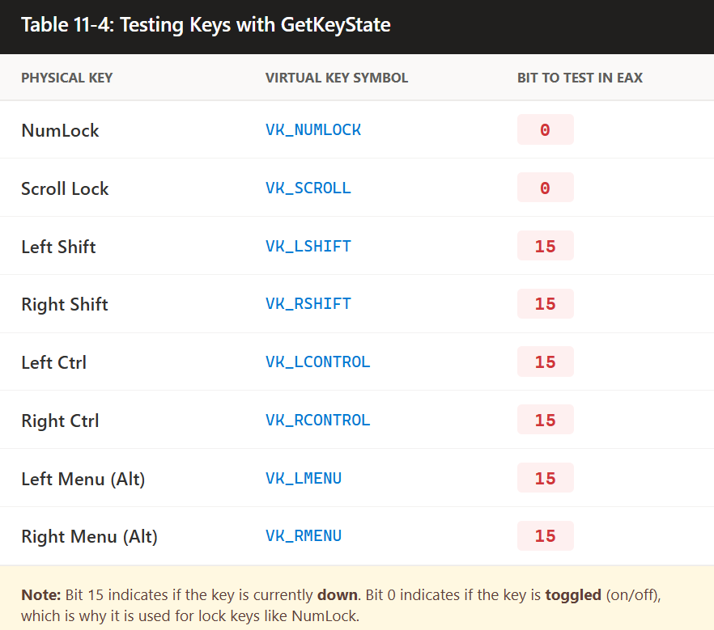

GetKeyState returns a value in **EAX**, which can be tested to determine the state of a key.

The program demonstrates checking the **NumLock** and **Left Shift** keys.

To check **NumLock**:

* Call GetKeyState with VK_NUMLOCK.
* Test **bit 0 (lowest bit) of AL**.
* If set, **NumLock is ON**.

To check **Left Shift**:

* Call GetKeyState with VK_LSHIFT.
* Test **bit 31 (highest bit) of EAX**.
* If set, the **Left Shift key is currently pressed**.

The program displays **messages** based on the test results to report the state of the keys.

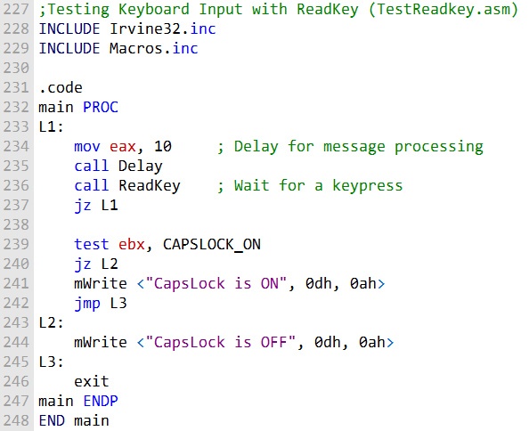

Program 2:

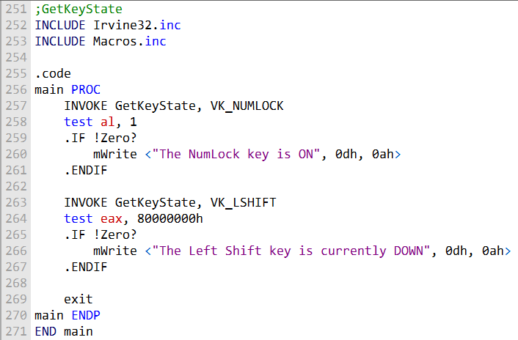

CONSOLE OUTPUT

I. WriteConsole Function

* Used to **write a string to the console** at the current cursor position.
* **Parameters**:
  + hConsoleOutput: Handle to the console output stream.
  + lpBuffer: Pointer to the array of characters to write.
  + nNumberOfCharsToWrite: Number of characters to write.
  + lpNumberOfCharsWritten: Pointer to receive the number of characters actually written.
  + lpReserved: Not used; set to 0.
* Advances the cursor just past the last character written.
* Can handle ASCII control characters (tabs, carriage returns, line feeds).
* The string **does not need to be null-terminated**.

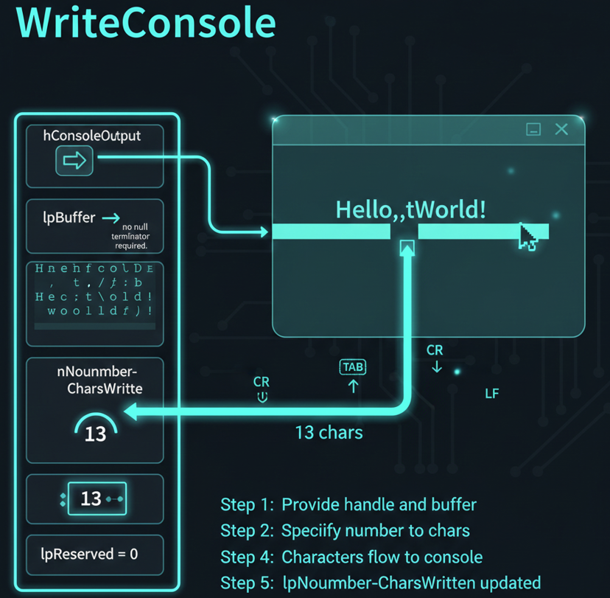

II. COORD Structure

Represents the **coordinates of a character cell** in the console screen buffer.

Origin is at the **top-left** of the console screen.

**Fields**:

* X (WORD): X-coordinate.
* Y (WORD): Y-coordinate.

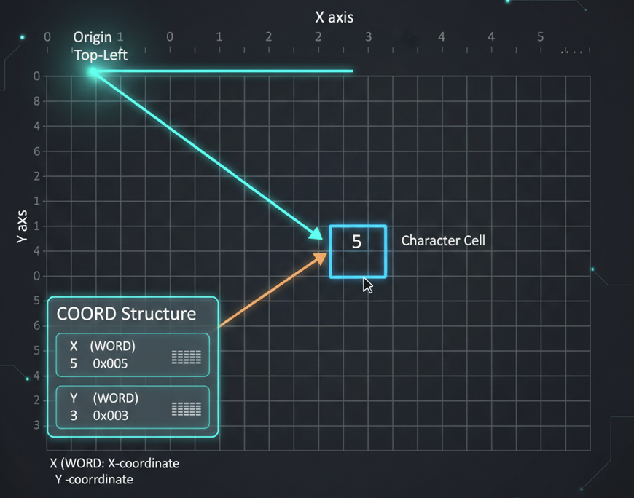

III. SMALL_RECT Structure

* Represents a **rectangular region** within the console window.
* Specifies **upper-left and lower-right corners** of the rectangle.
* Useful for defining **character cell regions** in the console.
* **Fields**:
  + Left (WORD): Left coordinate.
  + Top (WORD): Top coordinate.
  + Right (WORD): Right coordinate.
  + Bottom (WORD): Bottom coordinate.

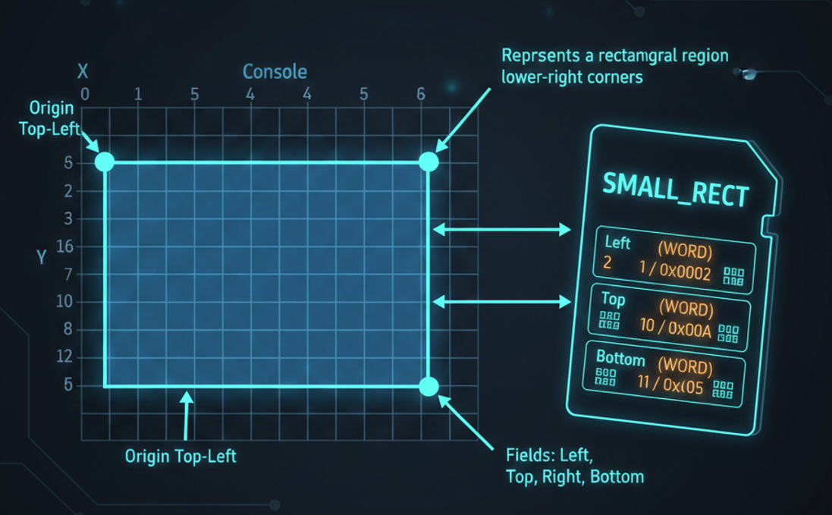

These structures are commonly used in **console-related Win32 functions** for managing and manipulating console windows.

WriteConsole is especially useful for **directly writing content to the console**.

***Example 1: WriteConsole function***

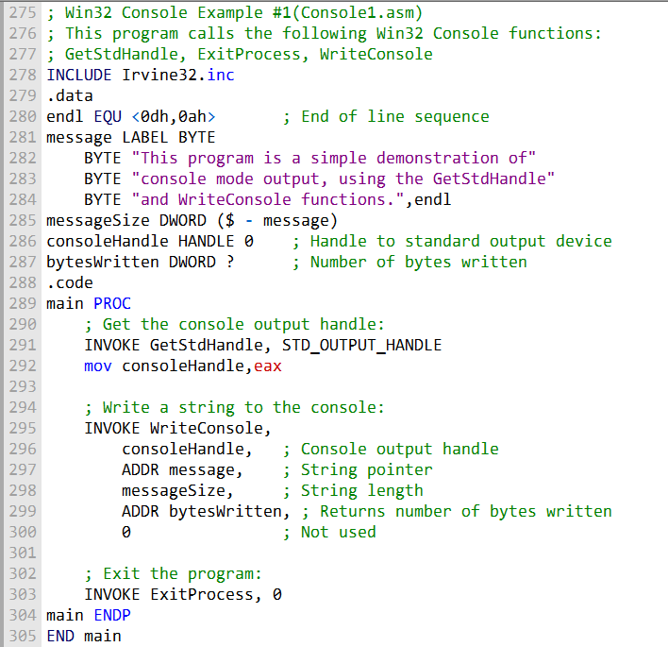

Console1.asm Program Overview

Demonstrates **GetStdHandle**, **WriteConsole**, and **ExitProcess** in a Win32 console application.

.data Section

* endl: End-of-line sequence (carriage return + line feed).
* message: Multiline text string to write to the console.
* messageSize: Stores the size of the message string.
* consoleHandle: HANDLE variable (initialized to 0) to store standard output handle.
* bytesWritten: DWORD variable to store the number of bytes written by WriteConsole.

.code Section (main procedure)

* INVOKE GetStdHandle, STD_OUTPUT_HANDLE:
  + Retrieves the handle to the standard output (console).
  + Stores the handle in consoleHandle.
* INVOKE WriteConsole:
  + Writes the message string to the console.
  + Parameters:
    - consoleHandle: Console output handle
    - ADDR message: Pointer to the message string
    - messageSize: Length of the message
    - ADDR bytesWritten: Pointer to receive number of bytes written
    - 0: Unused parameter
* INVOKE ExitProcess, 0: Exits the program.

Program Behavior

* Writes the message string to the console.
* Displays multiline text in the console window.
* Exits cleanly after writing the message.

The output will look like this:

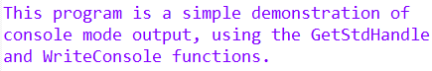

This code demonstrates how to use the **Win32 Console functions** to write a message to the console window.

The message is stored in the message variable and is written to the console using the **WriteConsole function**. Finally, the program exits using ExitProcess.

WriteConsoleOutputCharacter function - Writing to the Console Using Win32 Functions

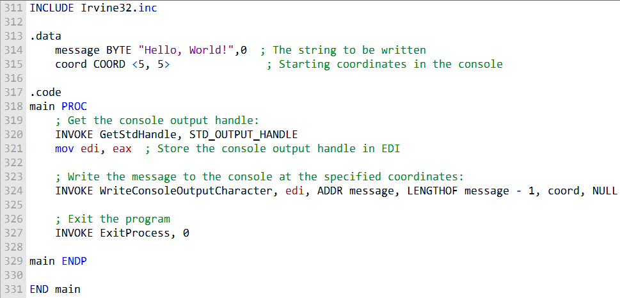

* **Purpose**: Demonstrates writing messages to the console window in a Win32 program.
* **Message Storage**: The message is stored in a variable (e.g., message).

WriteConsole Function

* Writes a string to the console at the **current cursor position**.
* Handles standard ASCII control characters like **carriage return (CR)** and **line feed (LF)**. Parameters:
  + hConsoleOutput: Handle to the console output.
  + lpBuffer: Pointer to the string to write.
  + nNumberOfCharsToWrite: Number of characters to write.
  + lpNumberOfCharsWritten: Pointer to receive the number of characters actually written.
  + lpReserved: Not used; set to 0.
* **Use Case**: Simple console output, writing sequentially from the current cursor position.

WriteConsoleOutputCharacter Function

* Writes an array of characters to **specific cells** in the console screen buffer.
* Text can wrap to the next line if it reaches the end of a line.
* **Does not** modify attribute values in the screen buffer.
* **Ignores ASCII control codes** like tab, CR, and LF.
* Parameters:
  + hConsoleOutput: Handle to the console output buffer.
  + lpCharacter: Pointer to the characters to write.
  + nLength: Number of characters to write.
  + dwWriteCoord: Coordinates (COORD structure) of the first cell to start writing (X = column, Y = row).
  + lpNumberOfCharsWritten: Pointer to receive the number of characters actually written.
* Return value: **Non-zero** if successful. **Zero** if failed.
* **Use Case**: Provides **precise control** over where text appears in the console, unlike WriteConsole.
* **ExitProcess Function -** Exits the program cleanly after writing messages.

FILE HANDLING

CreateFile Function

Creates a new file or opens an existing file.

Return Value:

* Returns a **handle** to the file if successful.
* Returns **INVALID_HANDLE_VALUE** if it fails.

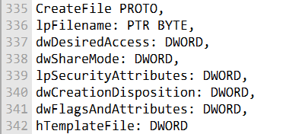

Parameters

1. **lpFilename**
   * Pointer to a null-terminated string with the file path.
   * Can be full path (C:\folder\file.txt) or just a filename (file.txt).
2. **dwDesiredAccess**
   * Specifies type of access to the file. Options include:
     + GENERIC_READ – read access
     + GENERIC_WRITE – write access
     + 0 – device query access
   * Flags can be combined with bitwise OR.
3. **dwShareMode**
   * Controls how other processes can access the file while it’s open:
     + FILE_SHARE_READ – others can read
     + FILE_SHARE_WRITE – others can write
     + 0 – no sharing
4. **lpSecurityAttributes**
   * Pointer to security structure. Usually NULL if no special security is needed.
5. **dwCreationDisposition**
   * Specifies action depending on file existence:
     + CREATE_NEW – create new, fails if exists
     + CREATE_ALWAYS – create new, overwrite if exists
     + OPEN_EXISTING – open existing, fails if not found
     + OPEN_ALWAYS – open if exists, create if not
     + TRUNCATE_EXISTING – open and truncate to zero, fails if not found
6. **dwFlagsAndAttributes**
   * File attributes and flags: e.g., FILE_ATTRIBUTE_NORMAL, FILE_ATTRIBUTE_HIDDEN, FILE_ATTRIBUTE_ARCHIVE.
7. **hTemplateFile**
   * Optional handle to a template file. Can supply attributes and extended attributes. Usually set to NULL.

Usage Notes

* dwDesiredAccess and dwShareMode can be combined using **bitwise OR**.
* dwCreationDisposition is **critical** for controlling whether a file is created, overwritten, or opened.
* WriteFile and ReadFile typically follow CreateFile for I/O operations using the returned handle.

Here's an example of how you might use the CreateFile function in assembly language to create or open a text file and get a handle to it:

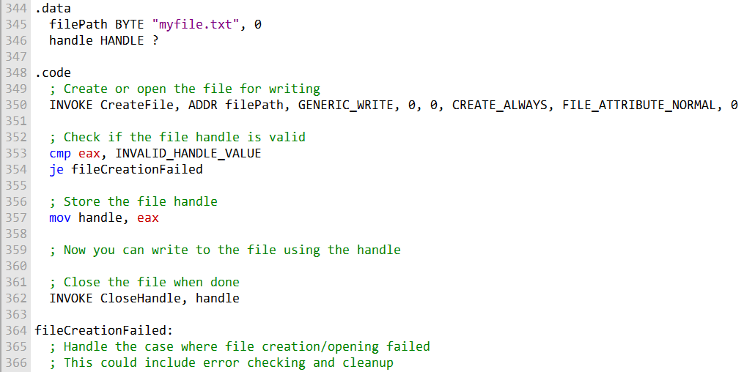

This code opens or creates the file "myfile.txt" for writing and checks if the operation was successful.

Combined Code:

Here's a single code example that demonstrates the creation and opening of files using CreateFile, and reading from a file using ReadFile.

It uses the file "mydata.txt" for illustration:

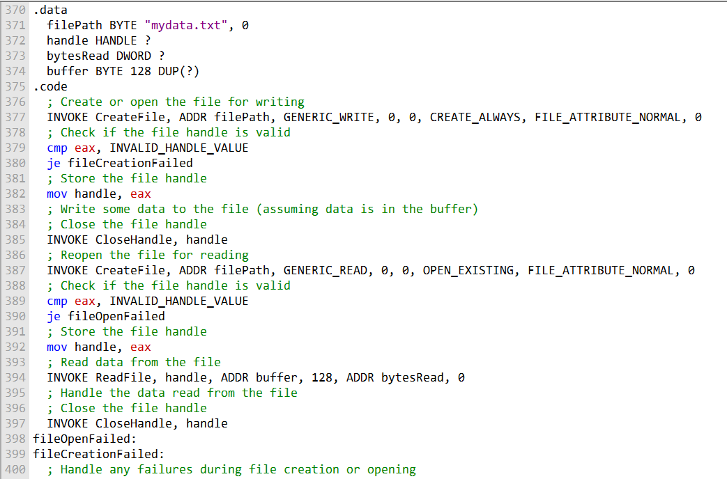

Things the User Can’t Read Directly from the Code and we have to explain:

* **CreateFile behavior**
  + Returns a **handle**, not the actual file contents; you need ReadFile or WriteFile to interact with data.
  + If it fails, INVALID_HANDLE_VALUE is returned, but **why it failed** isn’t obvious until you check GetLastError.
* **Access vs. sharing**
  + dwDesiredAccess only requests access; it does **not guarantee** other processes won’t access the file. That’s determined by dwShareMode.
  + Combining GENERIC_READ | GENERIC_WRITE doesn’t automatically prevent other processes from writing unless dwShareMode is set to restrict it.
* **Security attributes**
  + lpSecurityAttributes controls inheritance and permissions at the system level.
  + Even if set to NULL, default security rules apply, which might block access depending on the user or process permissions.
* **Creation disposition subtleties**
  + CREATE_NEW ensures you never overwrite existing files.
  + OPEN_ALWAYS can **both open or create** a file, which can lead to unexpected behavior if the file already exists.
  + TRUNCATE_EXISTING destroys the file’s previous content immediately; there’s no undo.
* **File attributes (dwFlagsAndAttributes)**
  + Attributes like FILE_ATTRIBUTE_HIDDEN or FILE_ATTRIBUTE_READONLY don’t prevent access programmatically but affect how the file is treated by the OS and some applications.
* **Template file (hTemplateFile)**
  + Rarely used, but if specified, new files can inherit extended attributes (like NTFS alternate data streams) from the template.
* **Closing files**
  + CloseHandle isn’t just cleanup—it flushes buffers and ensures **data integrity**. Forgetting to close a handle can corrupt files or leak system resources.
* **ReadFile behavior**
  + Synchronous vs asynchronous reading: lpOverlapped = NULL makes it synchronous.
  + The function fills a buffer and reports exactly how many bytes were read, which may be **less than requested** at the end of the file.
* **Error handling**
  + Most failures don’t crash the program—they require GetLastError to understand the cause (e.g., access denied, file not found, sharing violation).

WRITEFILE AND SETFILEPOINTER

WriteFile function

The WriteFile function is used to **write data to a file or any output handle** (like a console or screen buffer).

I. How it works:  
The function writes data starting at the file’s **current position pointer**. After the operation, the pointer automatically moves forward by the number of bytes actually written.

II. Parameters:

* hFile – handle to the file or output destination
* lpBuffer – pointer to the data buffer to write
* nNumberOfBytesToWrite – how many bytes to write
* lpNumberOfBytesWritten – receives the actual number of bytes written
* lpOverlapped – set to NULL for synchronous writes; used for asynchronous operations

III. Return value:

* Non-zero → success
* Zero → failure (use GetLastError to find out why)

IV. Things to keep in mind:

* **Partial writes:** Even if you request nNumberOfBytesToWrite, fewer bytes may be written (e.g., disk full). Always check lpNumberOfBytesWritten.
* **Handles:** Can write not just to files, but also to pipes, consoles, or other output handles.
* **Synchronous vs. asynchronous:** Synchronous writes block the calling thread; asynchronous writes require OVERLAPPED.

SetFilePointer Function

SetFilePointer moves the **current read/write position** in an open file, which is useful for **random access or appending data**.

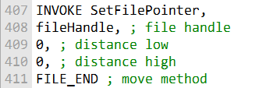

I. Parameters:

* hFile – handle to the open file
* lDistanceToMove – number of bytes to move the pointer (can be positive or negative)
* lpDistanceToMoveHigh – pointer to the high 32 bits of the distance (for files larger than 4 GB; use NULL if not needed)
* dwMoveMethod – starting point for the move:
  + FILE_BEGIN → absolute position from file start
  + FILE_CURRENT → relative to current pointer
  + FILE_END → relative to file end (easy for appending)

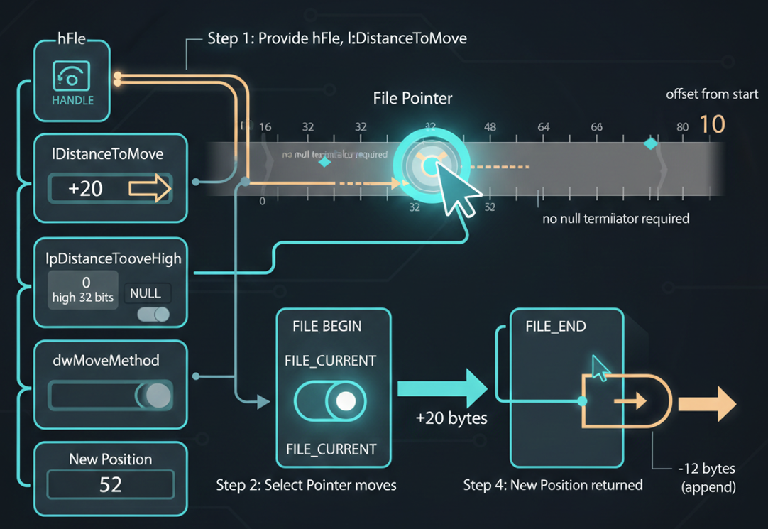

II. Hidden behaviors & tips:

* Moves the file’s **internal pointer**, which affects all subsequent ReadFile and WriteFile calls.
* Can handle **large files** via lpDistanceToMoveHigh.
* Supports **negative offsets** to move backward in the file.
* If the pointer cannot be set (e.g., negative position before file start), the function returns INVALID_SET_FILE_POINTER; call GetLastError to get details.

III. Quick Usage Example

**Appending data to a file:**

Move to the end of the file:

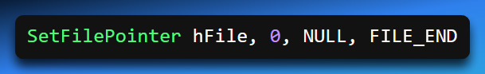

Write data:

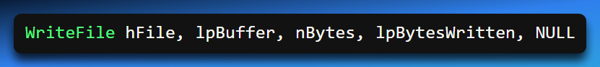

The file pointer automatically advances after the write.

These functions are essential for managing file access and writing data in Windows programming.

They are typically used in sequence:

* **SetFilePointer** positions the file pointer to the desired location.
* **WriteFile** writes data to that specific location.

Proper use of these functions ensures efficient and accurate file manipulation in Windows applications.

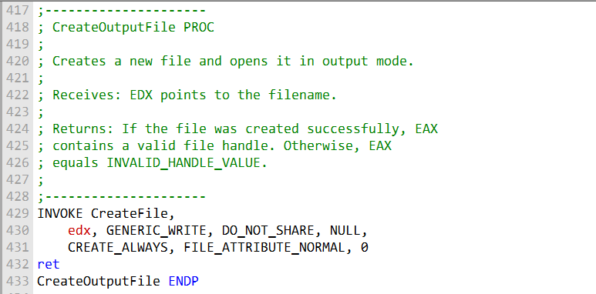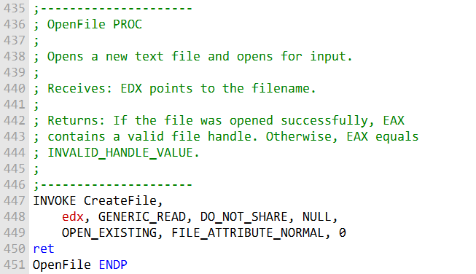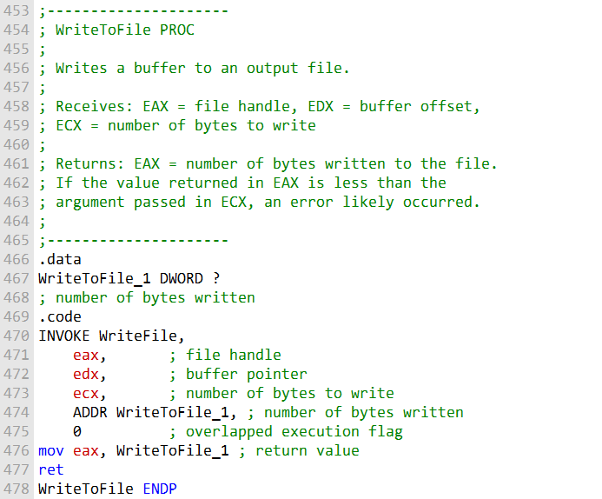

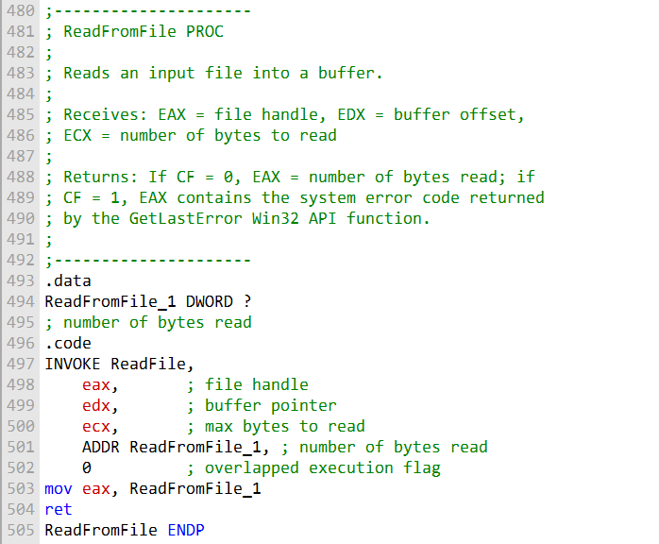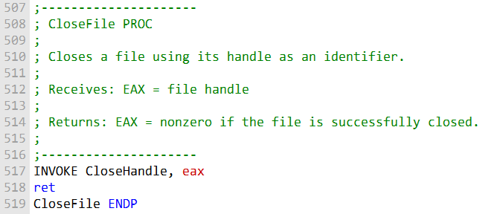

That was the first program to test your knowledge, now let's do the second one:

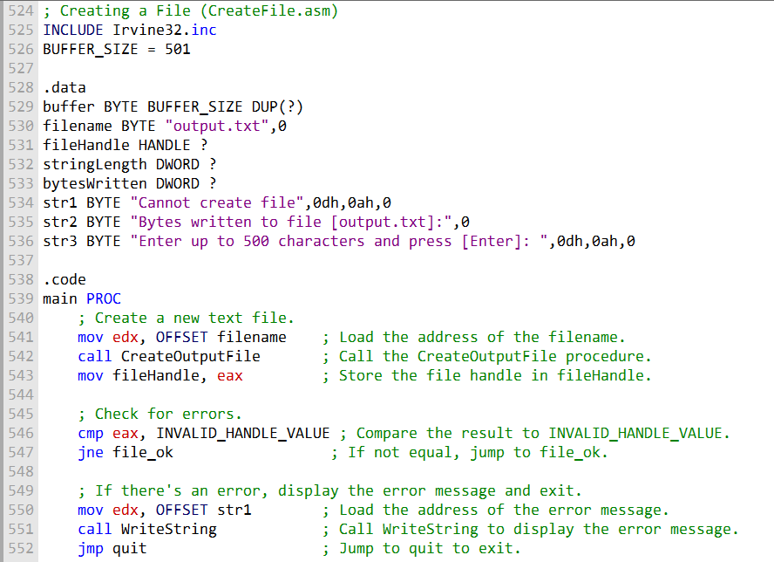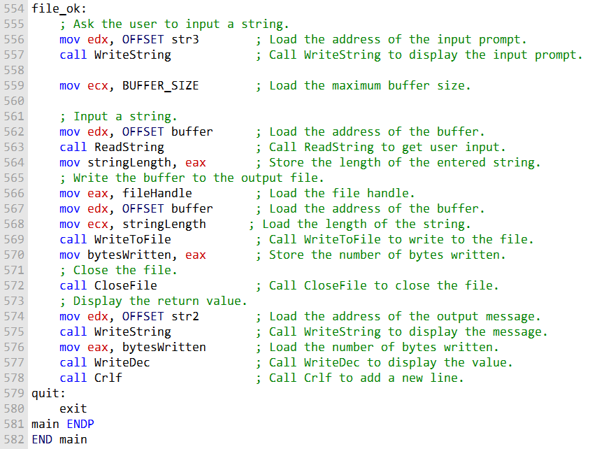

That's the second program.

Let's try another program:

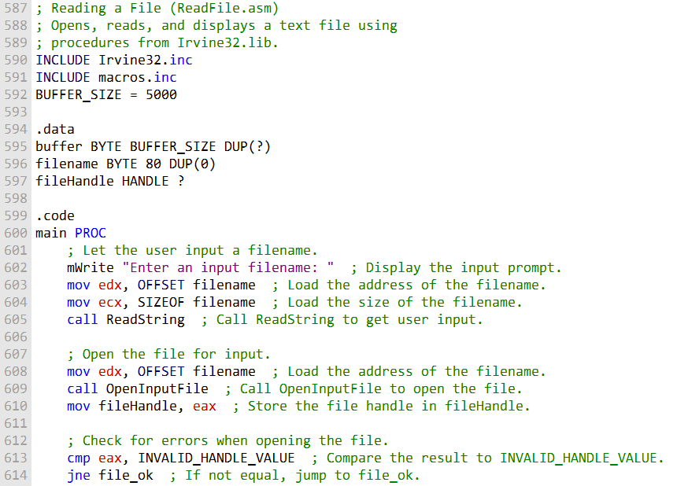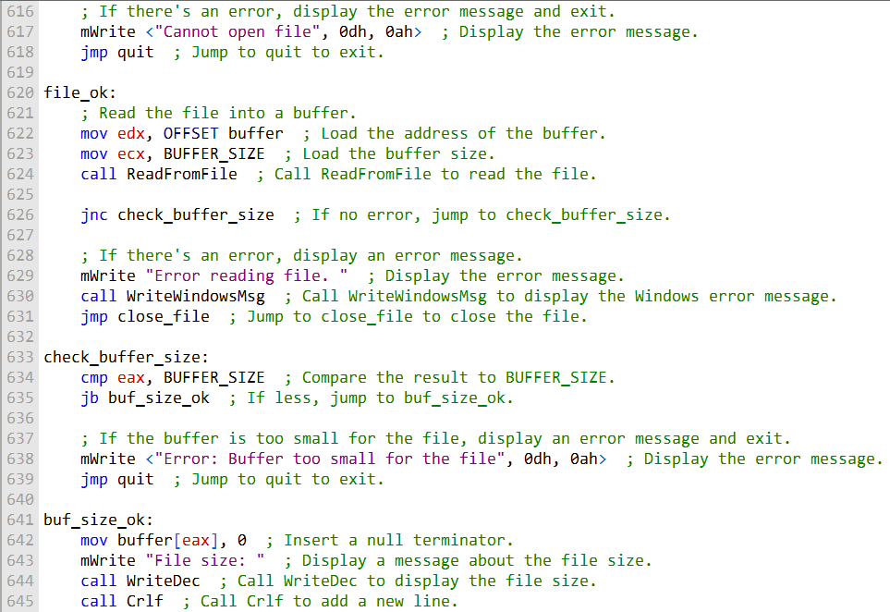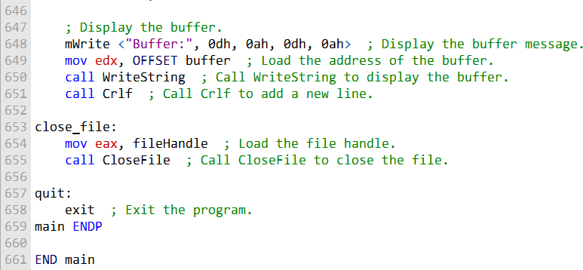

That's the 3rd program.

CONSOLE WINDOW MANIPULATION

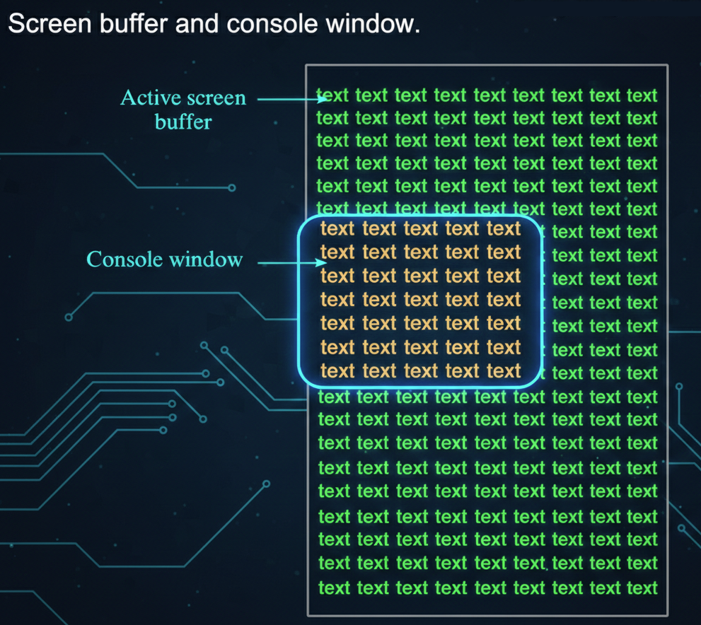

* **Screen Buffer:** Memory area storing characters and color attributes for the console.
* **Console Window:** The visible window displaying the contents of the screen buffer.

Key Functions

* **WriteConsoleOutput():**
  + Writes characters **and color attributes** to a rectangular block in the console buffer.
  + Can update a specific area without affecting the rest of the buffer.
* **ReadConsoleOutput():**
  + Reads characters **and color attributes** from a rectangular block in the console buffer.
  + Useful for saving or inspecting parts of the screen before modifying it.
* **SetConsoleCursorPosition():**
  + Moves the cursor to a specific location in the console buffer.
  + Affects where the next character will be displayed.

Screen Buffer Character Operations

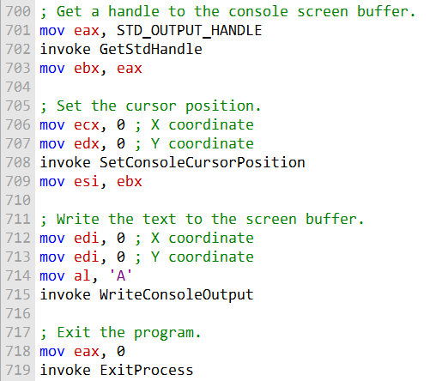

* Writing a character (e.g., 'A') to the **top-left corner** updates both the character and its color attribute in the screen buffer.
* The **cursor position is independent**—writing with WriteConsoleOutput doesn’t move the console cursor.
* Using **ReadConsoleOutput** allows you to read characters **and their color attributes** from any rectangular block of the screen buffer.
* These functions let you **manipulate the console display directly** without relying on high-level console output functions.
* Reading/writing is **coordinate-based**, using COORD structures for the X (column) and Y (row) positions.

Screen Buffer and Cursor Operations

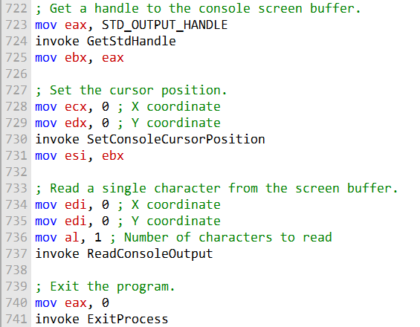

* **Reading a character:**
  + ReadConsoleOutput can retrieve a character **and its color attributes** from a specific location in the screen buffer.
  + Example: reading from the **top-left corner** fetches the first character displayed in the console.
* **Setting the cursor position:**
  + SetConsoleCursorPosition moves the cursor to any position in the screen buffer.
  + Example: setting it to the **middle of the console window** determines where the next character will appear when using functions like WriteConsole.
* These functions allow **direct manipulation of both content and cursor location**, independent of high-level output functions.
* Coordinates are handled using the **COORD structure** (X = column, Y = row).

SetConsoleCursorPosition – Middle of Console

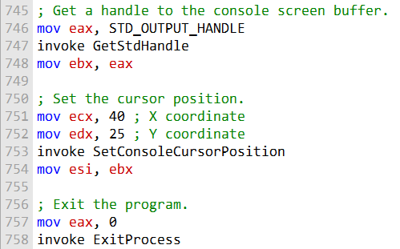

* The function moves the cursor to a **specific location** in the console buffer.
* To place it in the **middle of the console window**, you calculate coordinates as:
  + **X (column) = window width ÷ 2**
  + **Y (row) = window height ÷ 2**
* This determines **where the next character output will appear**.
* It does **not write any characters itself**; it only positions the cursor.
* Useful for **centering text** or controlling text layout precisely in console applications.

SetConsoleTitle, GetConsoleScreenBufferInfo, and SetConsoleWindowInfo

I. SetConsoleTitle

* Changes the **title of the console window**.
* You provide a string containing the new title.
* **Use case:** Customize the window title to reflect the program’s state or purpose.

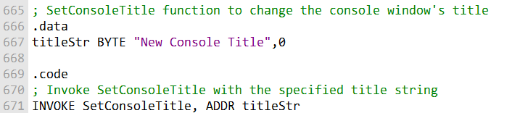

II. GetConsoleScreenBufferInfo

* Retrieves detailed information about the console window and screen buffer.
* Information is stored in a structure, typically named consoleInfo, which includes:
  + Size of the screen buffer
  + Current cursor position
  + Window dimensions
  + Text attributes
* **Use case:** Determine console layout, cursor location, or buffer size before performing advanced output operations.
* **Code can be inserted here** to call GetConsoleScreenBufferInfo and fill the consoleInfo structure.

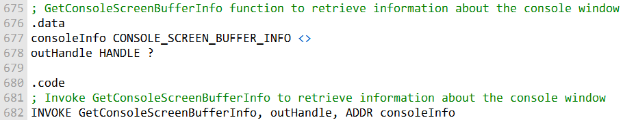

This code shows how to use the **GetConsoleScreenBufferInfo function** to obtain information about the console window, including screen buffer size, cursor position, and other details. The retrieved information is stored in the consoleInfo structure.

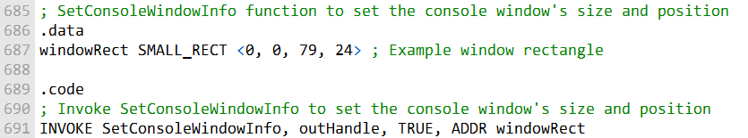

III. SetConsoleWindowInfo

* Sets the **size and position** of the console window relative to its screen buffer.
* You define the new dimensions and location using a structure, typically called windowRect.
* **Use case:** Resize or reposition the console window for better text layout or UI alignment.
* **Code can be inserted here** to call SetConsoleWindowInfo with the desired window rectangle.

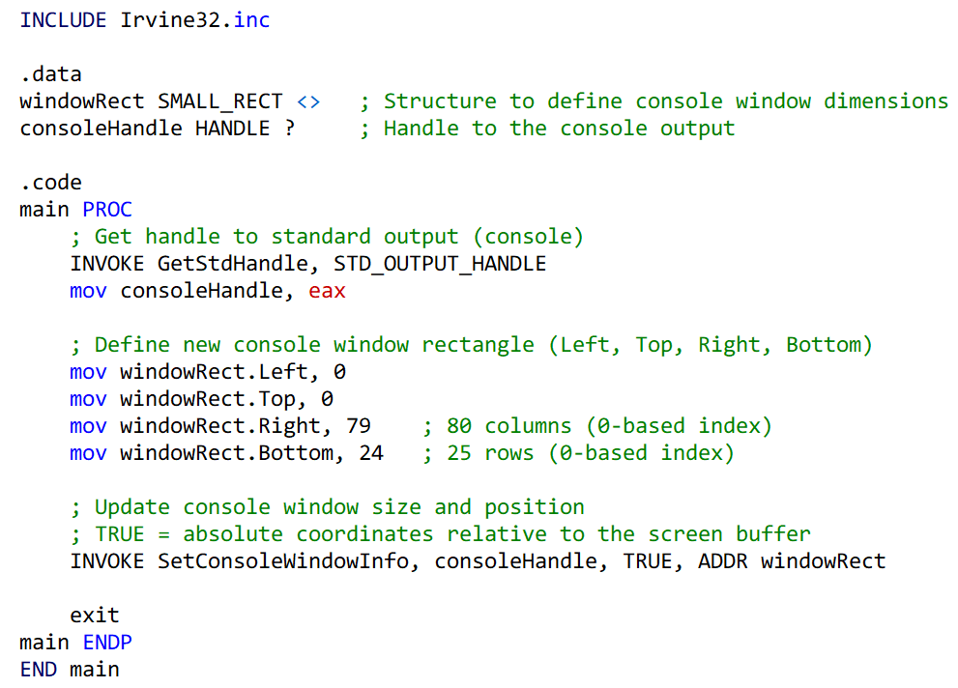

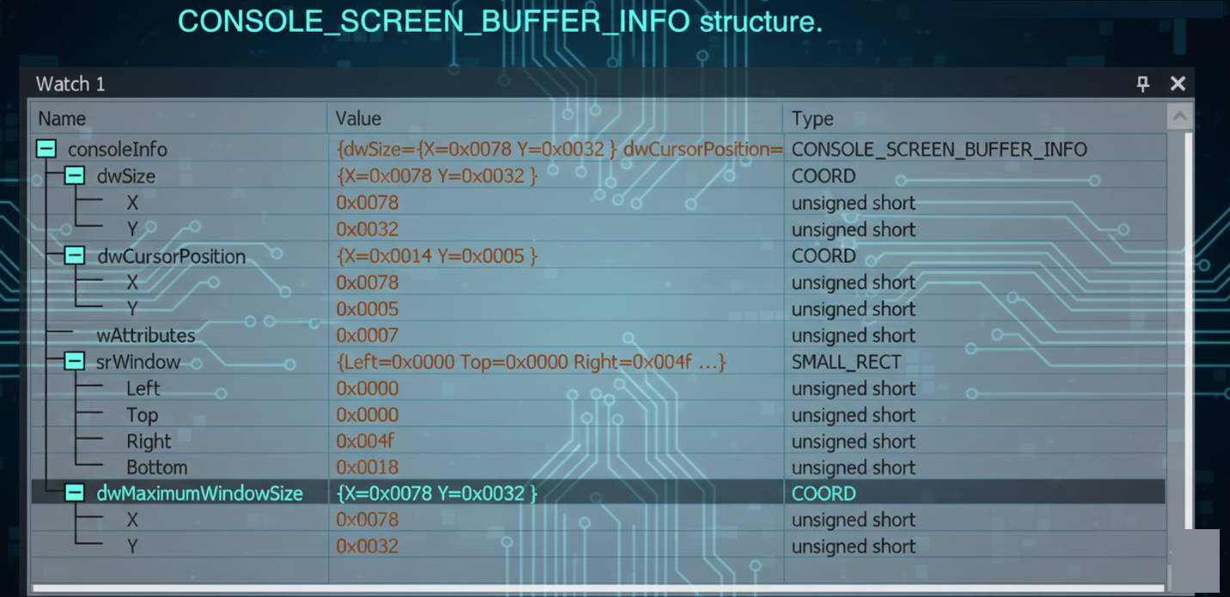

Scroll.asm program:

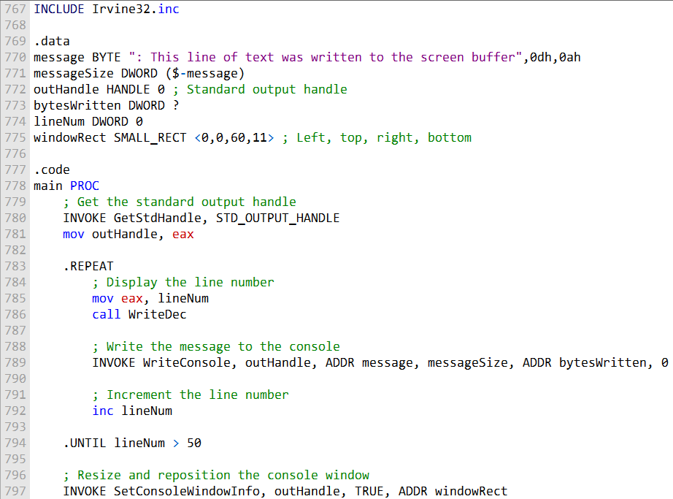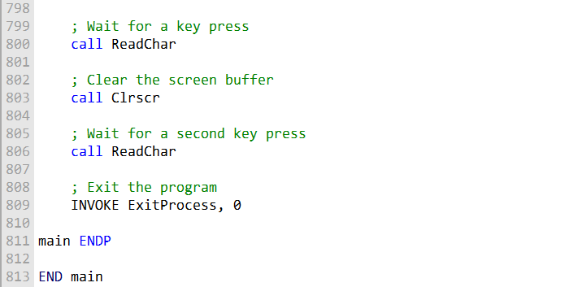

This code simulates scrolling the console window by writing lines of text to the screen buffer and then resizing and repositioning the console window using SetConsoleWindowInfo.

After running this program, press a key to trigger the scroll, clear the screen, and exit the program.

Another example:

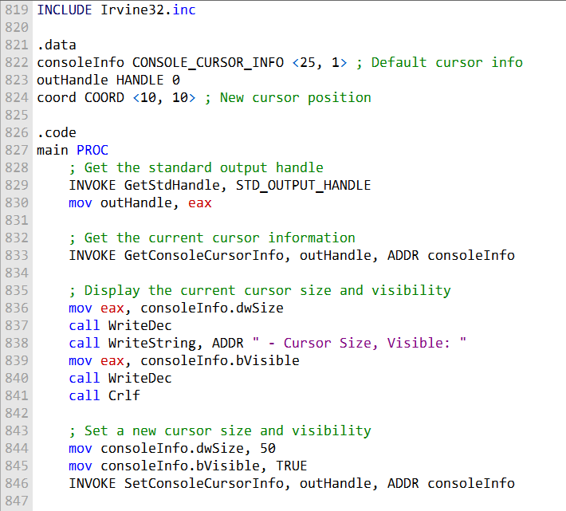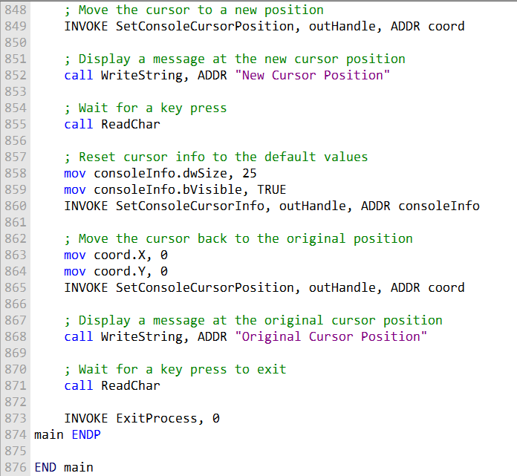

Summary of that program:

* **Retrieve current cursor info:** Uses GetConsoleCursorInfo to store the current size and visibility of the cursor.
* **Change cursor appearance:** Modifies cursor size and visibility using SetConsoleCursorInfo.
* **Move the cursor:** Uses SetConsoleCursorPosition to position the cursor at a new location in the console window.
* **Display message:** Writes text to the console at the new cursor position.
* **Restore original cursor:** Resets the cursor size and visibility to the values retrieved at the start.
* **Wait for key press:** Pauses the program using a key press before exiting, ensuring the user can see the results.

SETTING TEXT COLOR

SetConsoleTextAttribute

* Sets the foreground and background colors for all text written afterward.
* Requires the console output handle and a combined color attribute.
* Changes apply to subsequent text output until another color change.

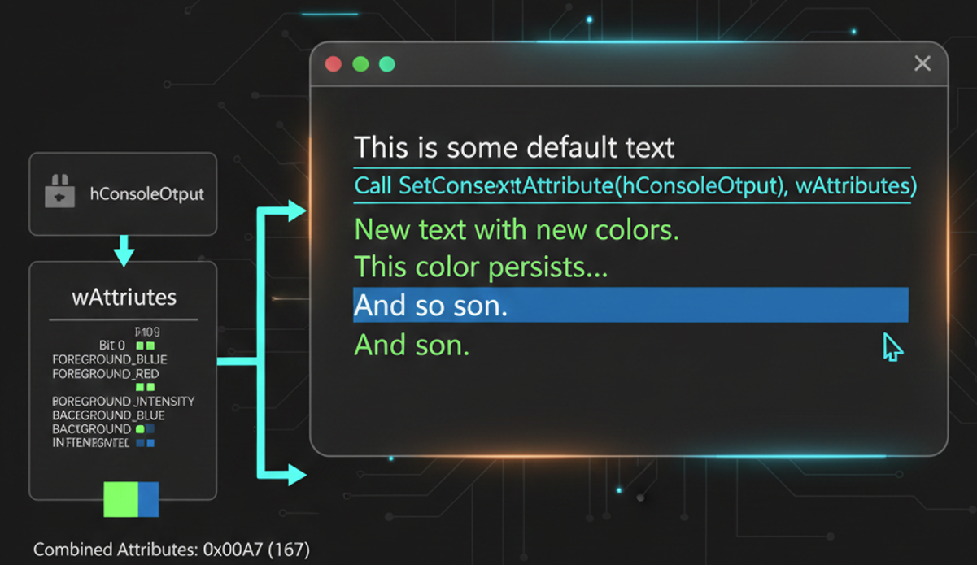

WriteConsoleOutputAttribute

* Sets text attributes (like color) for specific cells in the console screen buffer.
* Requires: an array of attributes, the number of attributes, starting coordinates (COORD), and a variable to receive the count of cells modified.
* Allows fine-grained control over colors of individual characters rather than the whole output.

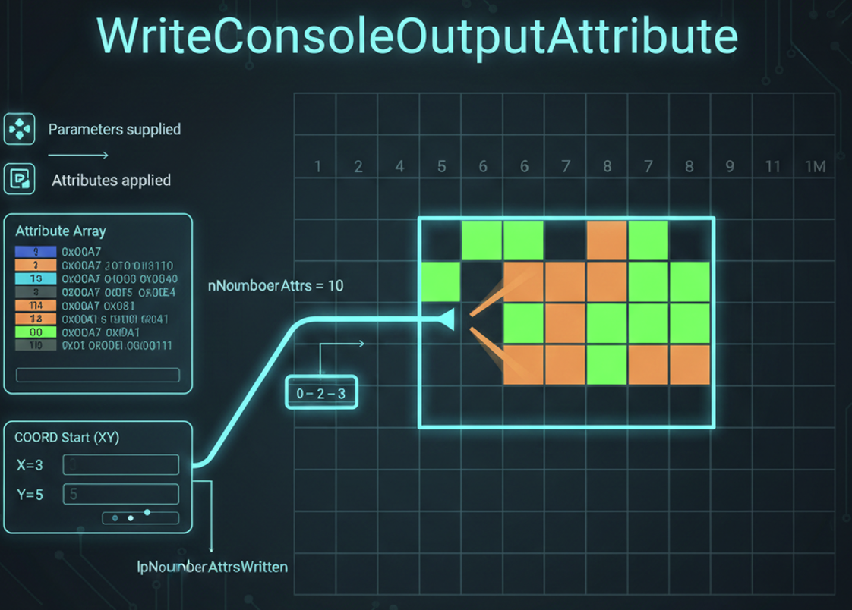

Use Case / Example Program

* Display different characters with varying colors.
* Can mix foreground and background colors for emphasis or visual effects.
* Useful for creating colored menus, status bars, or highlighting in console apps.

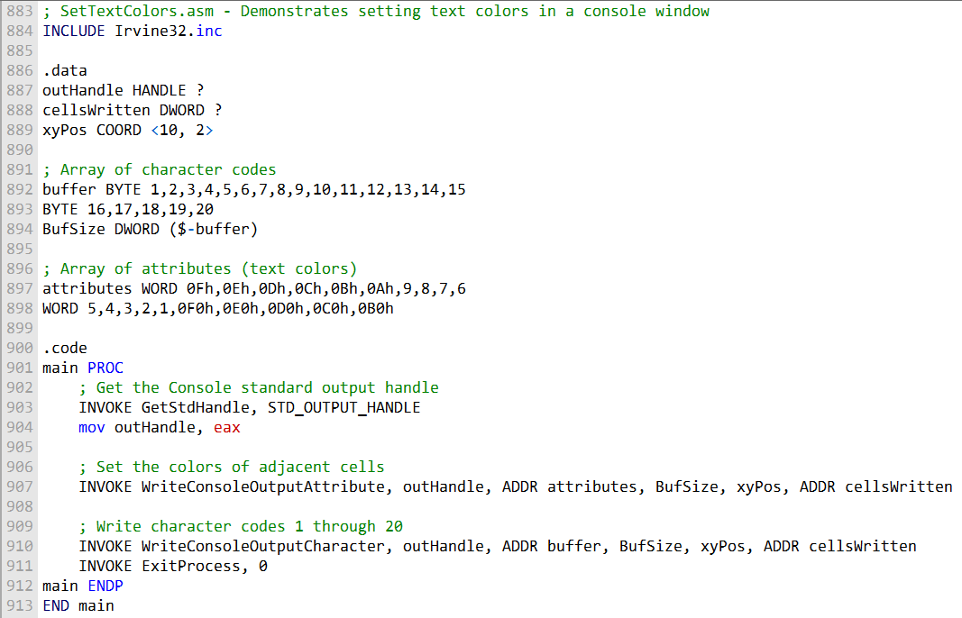

**Purpose:** Display characters 1–20 with different text colors in the console.

**Attributes Array:** Specifies the color for each character. Each element represents a foreground/background color for a specific character.

**WriteConsoleOutputCharacter / WriteConsoleOutputAttribute:**

* Characters are written to the console buffer at a specified location.
* Attributes array is applied so each character appears in its defined color.

**Result:** Console shows colorful text output where each character can have a unique color.

**Customization:** Modify the attributes array to change foreground/background colors or color patterns.

**Use Case:** Useful for menus, highlighting, or creating visually distinct console interfaces.

TIME, WINAPI AND ASSEMBLY

I. File Time Functions

* **CompareFileTime:** Compares two 64-bit file times to determine their chronological order.
* **DosDateTimeToFileTime:** Converts MS-DOS date/time values to 64-bit file time for compatibility with older formats.
* **FileTimeToDosDateTime:** Converts 64-bit file time back to MS-DOS date/time.
* **FileTimeToLocalFileTime:** Converts a UTC file time to local file time.
* **LocalFileTimeToFileTime:** Converts local file time to UTC-based file time.
* **FileTimeToSystemTime:** Converts 64-bit file time to a SYSTEMTIME structure with detailed date and time.
* **SystemTimeToFileTime:** Converts SYSTEMTIME to 64-bit file time.

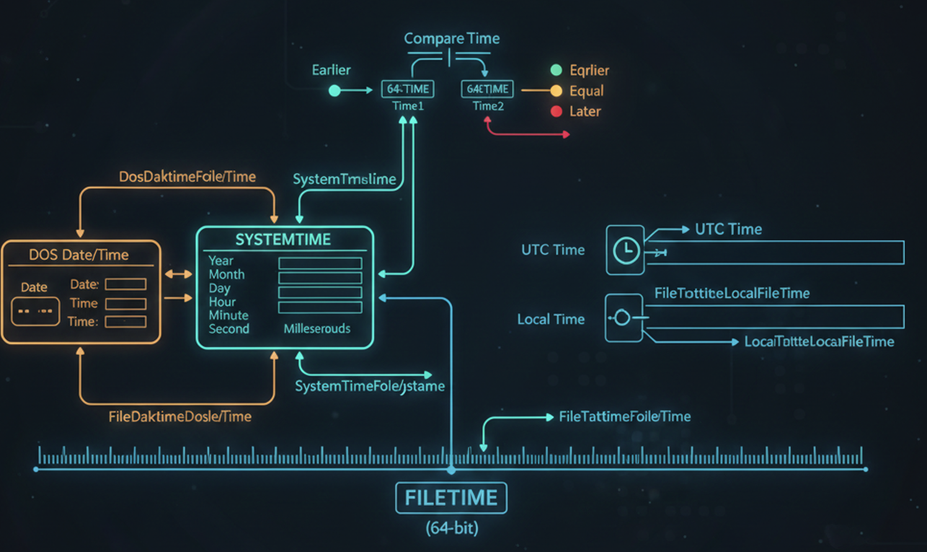

II. File Timestamp Functions

* **GetFileTime:** Retrieves a file’s creation, last access, and last modification times.
* **SetFileTime:** Sets a file’s creation, last access, or last modification times.

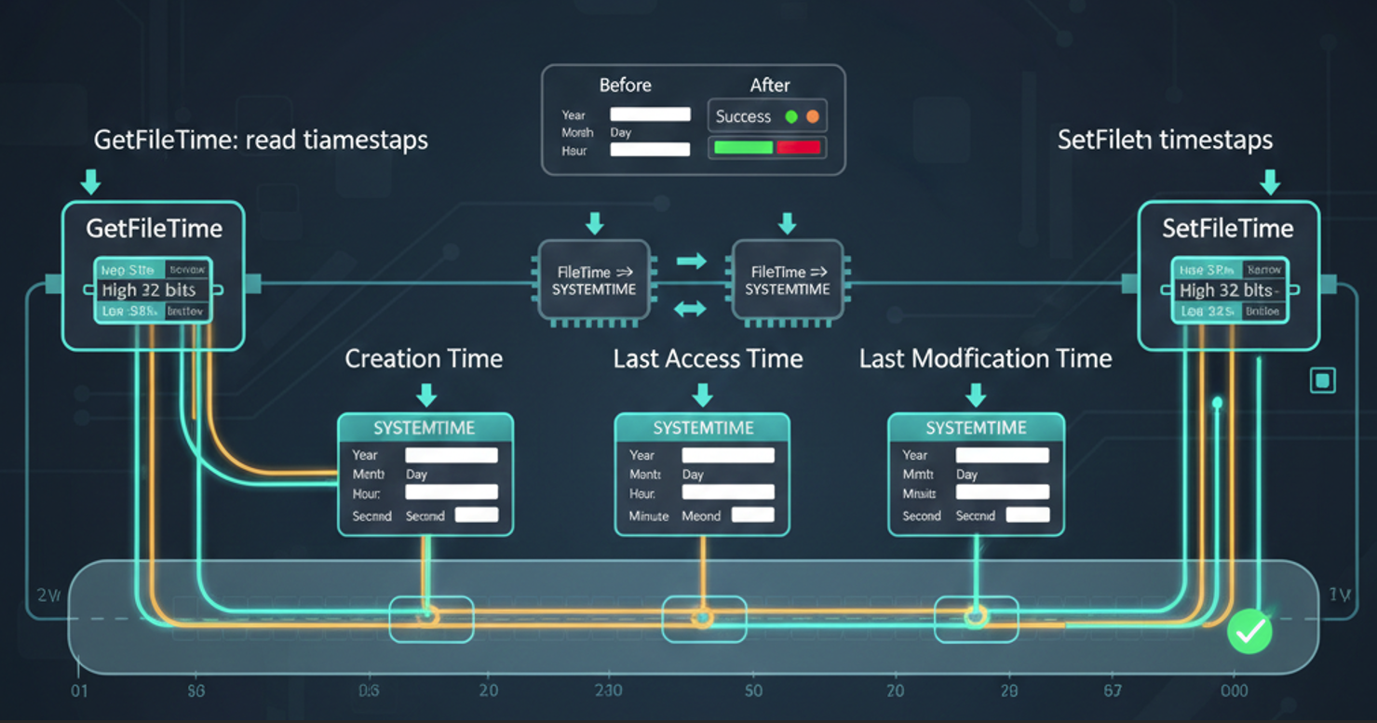

III. System Time Functions

* **GetLocalTime:** Retrieves the current local system date and time.
* **SetLocalTime:** Sets the system’s local date and time.
* **GetSystemTime:** Retrieves the current UTC system date and time.
* **SetSystemTime:** Sets the UTC system date and time.
* **GetSystemTimeAsFileTime:** Retrieves current UTC system time as a 64-bit file time.

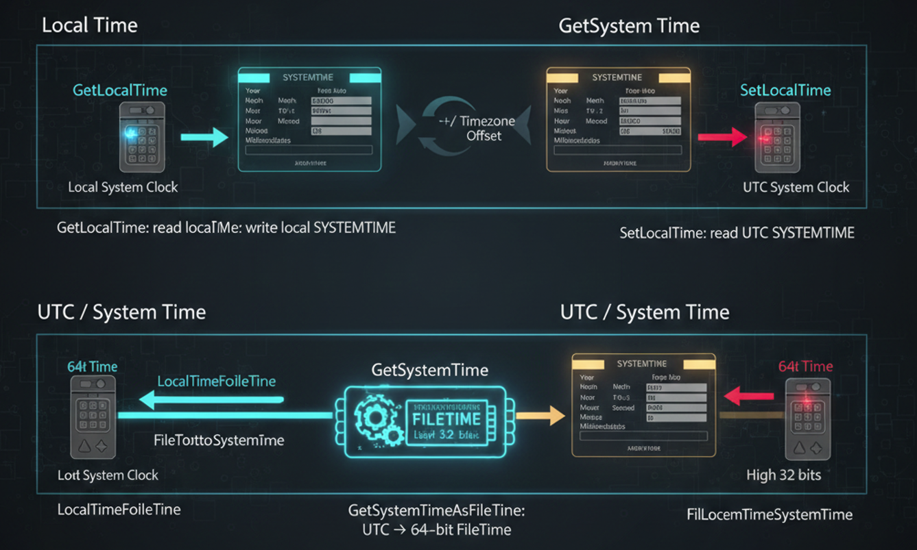

IV. Time Adjustment Functions

* **GetSystemTimeAdjustment:** Checks if the system applies periodic time adjustments (like DST).
* **SetSystemTimeAdjustment:** Enables or disables periodic adjustments to the system clock.

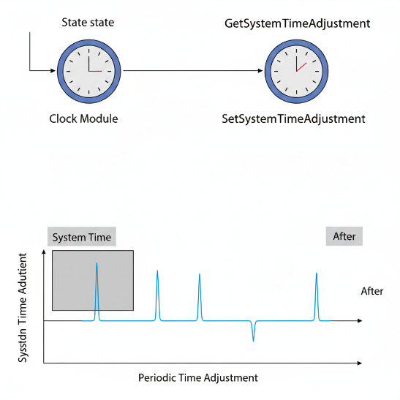

V. Time Zone Functions

* **GetTimeZoneInformation:** Retrieves the system’s current time-zone settings.
* **SetTimeZoneInformation:** Sets the system’s time-zone parameters.
* **SystemTimeToTzSpecificLocalTime:** Converts UTC time to local time for a specific time zone.

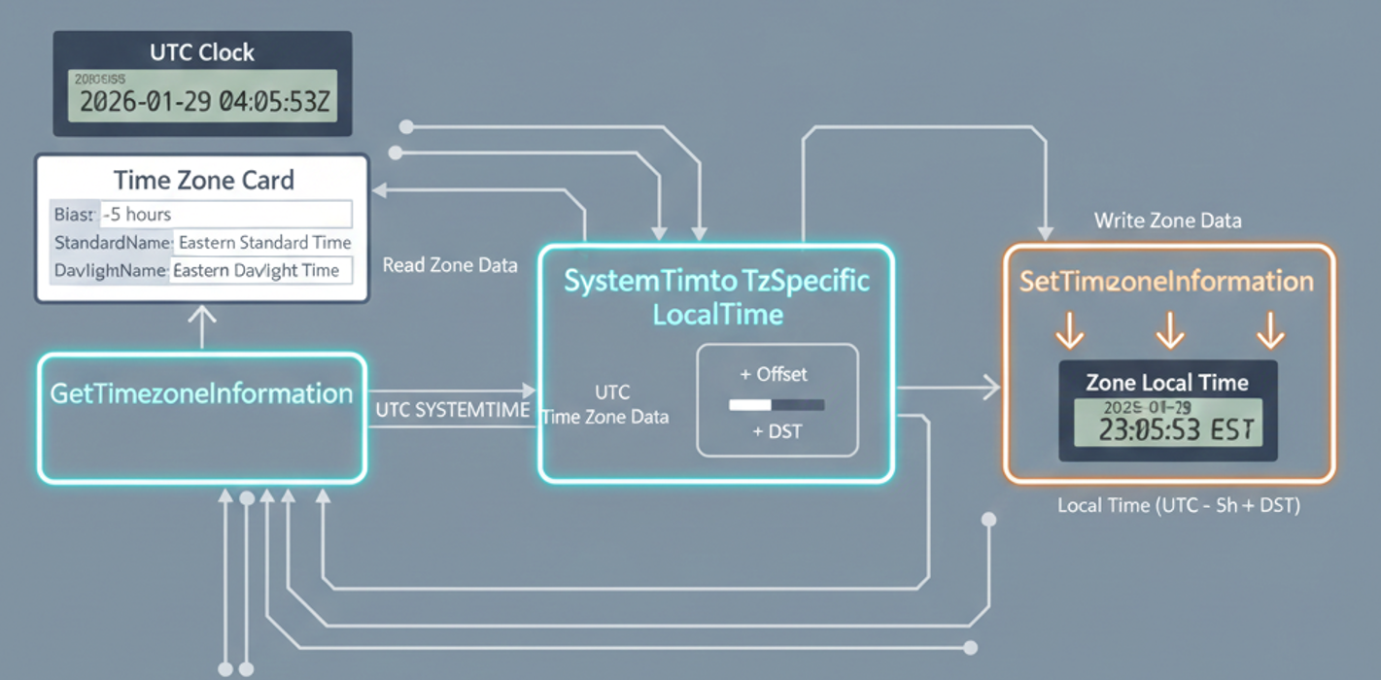

V. Utility / Interval Functions

* **GetTickCount:** Returns milliseconds since system start (system uptime). Useful for timing and measuring intervals.



**✅** Summary

These functions together allow you to:

* Read/write file timestamps.
* Convert between local, UTC, and MS-DOS times.
* Retrieve and set system time and local time.
* Handle time zones.
* Implement timers or measure intervals.

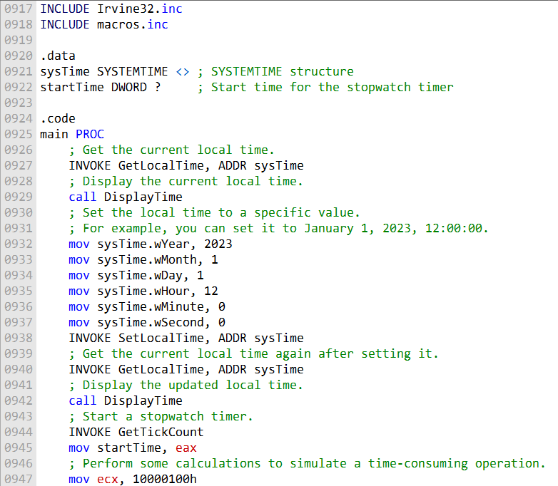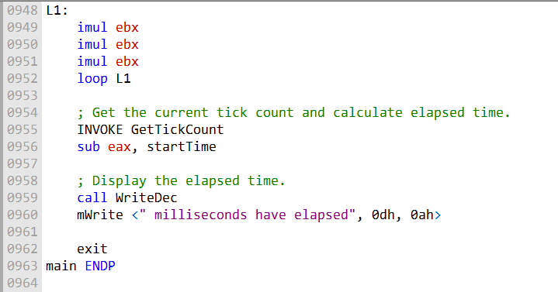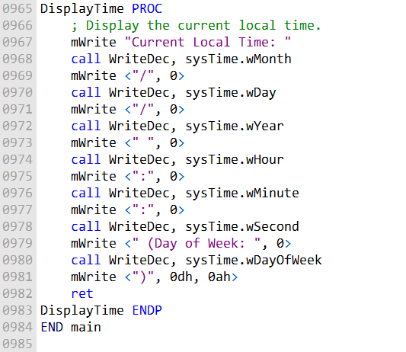

SYSTEMTIME Structure

* Holds detailed date and time information:
  + Year, Month, Day of Week, Day of Month
  + Hour, Minute, Second, Millisecond
* Used by Win32 API functions like GetLocalTime and SetLocalTime.

GetLocalTime Function

* Retrieves the current local date and time from the system clock.
* Fills a SYSTEMTIME structure passed as a pointer.
* Used to display or process the current local time.

SetLocalTime Function

* Sets the system’s local date and time.
* Takes a SYSTEMTIME structure containing the desired date/time.
* Allows programmatic adjustment of system time.

GetTickCount Function

* Returns the number of milliseconds since the system started.
* Useful for timing operations or measuring elapsed time.
* Does not take parameters; returns value in EAX.

DisplayTime Procedure

* Custom procedure to display components of a SYSTEMTIME structure:
* Year, Month, Day, Hour, Minute, Second, Day of Week
* Uses write functions to output these values to the console.

Program Flow

1. Retrieve and display current local time using GetLocalTime.
2. Set local time to a specific value using SetLocalTime.
3. Retrieve and display the updated local time.
4. Perform a time-consuming operation (loop) and measure duration with GetTickCount.
5. Display the elapsed time.

Sleep Function

* Introduces a pause/delay in program execution.
* Takes a parameter specifying the duration in milliseconds.
* Puts the processor in a low-power wait state until the delay elapses.

GetDateTime Procedure

* Retrieves current date and time in Win32 FILETIME format:
  1. Calls GetLocalTime to populate a SYSTEMTIME structure.
  2. Converts SYSTEMTIME to FILETIME using SystemTimeToFileTime.
  3. Stores the result as a 64-bit quadword, splitting it into two doublewords.
* Returns the current date and time as a 64-bit value representing 100-nanosecond intervals since January 1, 1601.

Summary

* SYSTEMTIME + GetLocalTime/SetLocalTime → Reading and modifying local system time.
* GetTickCount → Measuring elapsed time for operations.
* Sleep → Introducing controlled delays.
* GetDateTime → Retrieving time in FILETIME format for precise timing or logging.

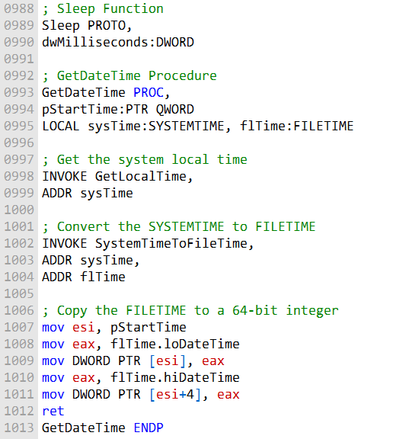

Sleep Function

The Sleep function lets your program **pause execution for a specified amount of time**, which can be very useful for timing, delays, or controlling program flow.

**How it works:**

* Place the number of milliseconds to pause into the EAX register.
* Call the Sleep function.
* After the specified time elapses (or if interrupted), execution resumes at the next instruction.

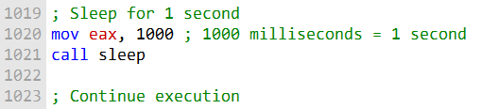

Important details:

* **Interruptions:** The sleep can be interrupted by events such as a timer interrupt. In that case, your program resumes immediately, even if the full delay hasn’t passed.
* **System call:** Sleep is implemented as a system call, so it interacts with the kernel.
* **Blocking:** If another process is holding the kernel lock, your sleep may be delayed until the lock is released.
* **Low-power mode:** The processor may enter a low-power state during sleep. This saves energy but can slightly delay other processes.

**Key takeaway:**  
Sleep is a simple but powerful tool to **control program timing**, but you need to keep in mind that external events and system conditions can affect the actual sleep duration.

GetDateTime Procedure

The GetDateTime procedure retrieves the **current date and time** and stores it in a **64-bit quadword**.

* You can integrate it into your MASM programs whenever you need to **log time, timestamp events, or calculate durations**.
* The value returned can be processed or converted into a human-readable format as needed.

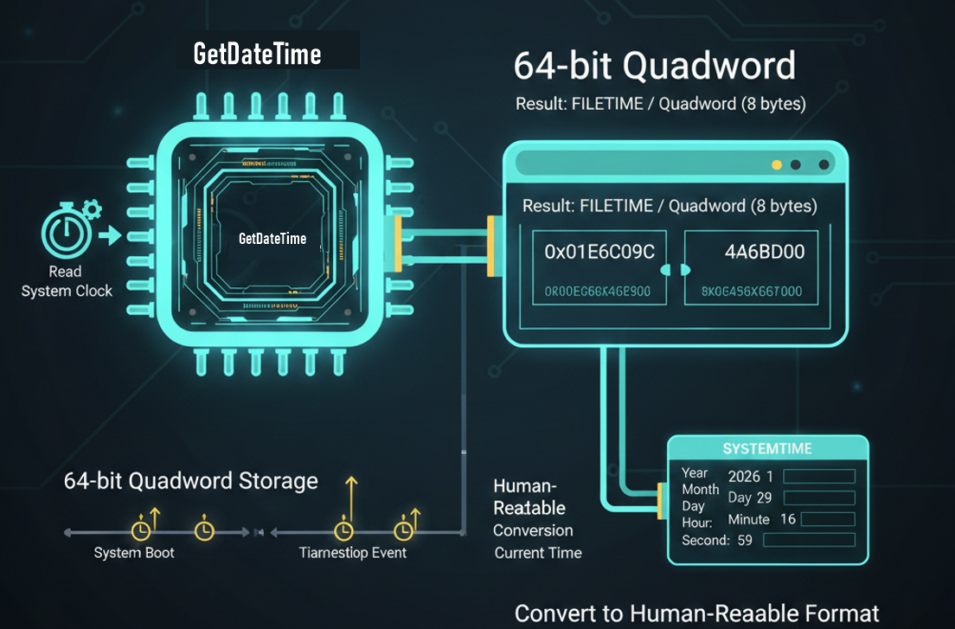

✅ Summary:

* Use Sleep to pause program execution for a set duration.
* Use GetDateTime to retrieve the current date and time in a format you can store or manipulate.
* Both functions are simple to use but can be influenced by interrupts, kernel activity, and system timing behavior.

CALLING 64-BIT WINAPI FUNCTION IN MASM

Steps to Call a 64-bit Windows API Function in MASM

**Reserve Shadow Space**

* Subtract at least 32 bytes from RSP (stack pointer) for the function’s shadow space.

**Align Stack**

* Ensure RSP is aligned to a 16-byte boundary before the call.

**Pass Arguments in Registers**

* First four arguments go in registers (in order):
  + RCX → 1st argument
  + RDX → 2nd argument
  + R8 → 3rd argument
  + R9 → 4th argument

**Push Extra Arguments on Stack**

* If there are more than four arguments, push the remaining ones onto the stack.

**Call the Function**

* Use the call instruction with the function name.

**Restore Stack**

* Add back the value subtracted from RSP to restore the original stack pointer.

**Return Value**

* The function returns a 64-bit integer in RAX.

Calling WriteConsoleA Function (64-bit Windows API)

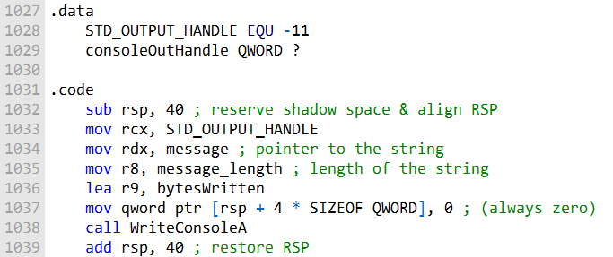

* **Arguments:**
  1. Console handle (hConsoleOutput)
  2. Pointer to the string to write (lpBuffer)
  3. Length of the string to write (nNumberOfCharsToWrite)
  4. Pointer to a variable to store number of bytes written (lpNumberOfCharsWritten)
  5. Dummy parameter, typically set to 0 (lpReserved)
* **Important Notes:**
  + The first **four arguments** are passed in **RCX, RDX, R8, R9** registers.
  + Shadow space of at least **32 bytes** must be reserved on the stack, even if unused.
  + Return value is in **RAX**; non-zero indicates success.
  + bytesWritten variable stores the number of bytes actually written and can be checked after the call.

Creating a Graphical Windows Application

1. **Include Required Libraries and Headers**
   * Libraries: kernel32.lib, user32.lib
   * Headers: contain structures, constants, and function prototypes (e.g., Windows.h)
2. **Create Main Window**
   * Use CreateWindowEx() to create the window.
3. **Display the Window**
   * Use ShowWindow() to show the main window on the screen.
4. **Handle Mouse Events**
   * Respond to messages like WM_MOUSEMOVE and WM_LBUTTONDOWN in the window procedure.
5. **Display Message Boxes**
   * Use MessageBox() to show alerts, notifications, or dialogs.

Here is a simple example of a graphical Windows application in assembly language:

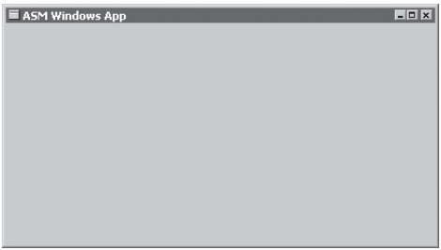

Read the code file - **GraphicalWindow.asm**

Ignore this program, it's just a trial program:

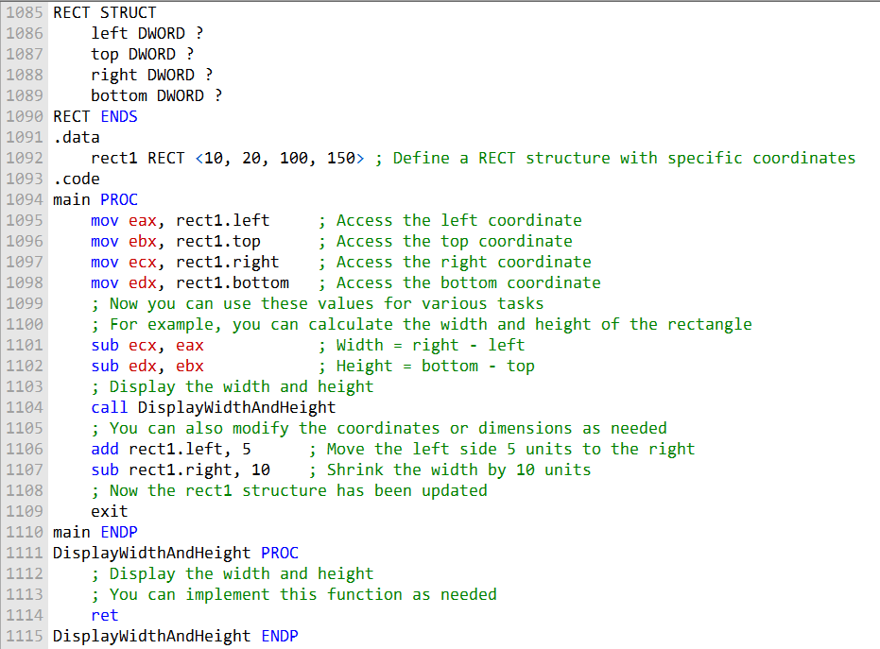

Read **GraphicalWindow2.asm**

And then finish off with the **GraphicalWindow3.asm**

**WinMain** - Entry point; initializes program, registers window class, creates main window, shows greeting, and starts the message loop.

**WinProc**

1. Handles messages/events like:
   * WM_CREATE → Display “application loaded” popup
   * WM_LBUTTONDOWN → Display “clicked mouse” popup
   * WM_CLOSE → Display “closing” popup & quit
2. Other messages → forwarded to DefWindowProc.

**ErrorHandler**

* + Called if registration or window creation fails.
  + Retrieves system error message and shows it in a MessageBox.
  + Frees memory allocated for error message.

1. **MessageBox Demos** - Shows how to display popups for various events, similar to the C version provided.
2. **Supports Multiple Features Together** - Combines greeting popup, left-click message, close message, and error handling into one MASM program.

DYNAMIC MEMORY

Dynamic memory allocation is the process of allocating memory **at runtime** during program execution.

This contrasts with **static memory allocation**, where memory is allocated at **compile time**.

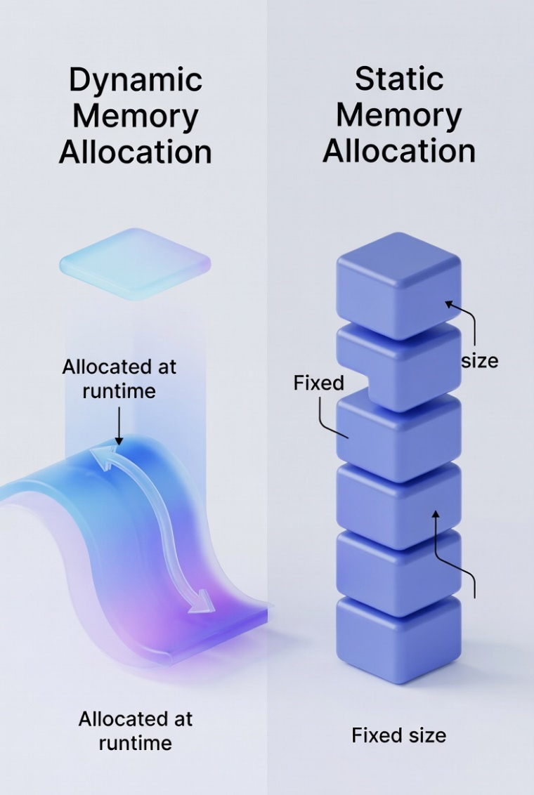

Methods of Dynamic Memory Allocation

1. **Using System Calls**
   * Make calls to the operating system to allocate and free memory.
   * Example: Windows API functions like HeapAlloc, HeapFree, GlobalAlloc, and VirtualAlloc.
2. **Implementing a Heap Manager**
   * Create your own data structures and algorithms to manage memory.
   * More flexible but requires careful design to avoid fragmentation or leaks.

Steps for Dynamic Memory Allocation Using System Calls

1. **Allocate memory**
   * Call a Windows API function to allocate a memory block.
   * The function returns a pointer to the allocated memory.
2. **Use the memory** - Access or modify the memory as needed for program operations.
3. **Deallocate memory**
   * Call a system function to free the allocated memory.
   * Ensures that memory is returned to the system and prevents leaks.

Common Win32 API Functions for Dynamic Memory Allocation

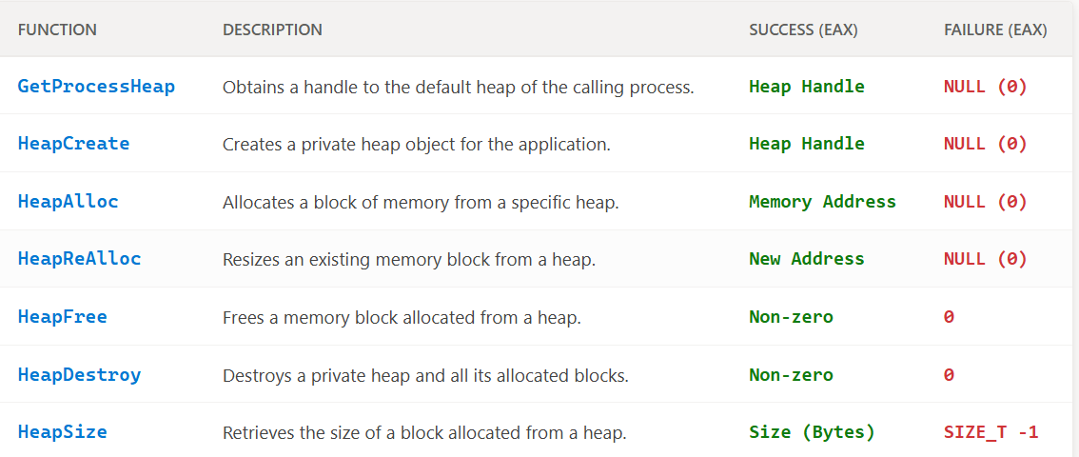

* Always **pair every allocation with a deallocation** to avoid memory leaks.
* System calls handle most of the memory management for you, unlike custom heap managers.
* Dynamic allocation is especially useful when the program **doesn’t know the exact memory size** it will need at compile time.

Win32 Heap Functions

* **GetProcessHeap()**
  + Returns a handle to the **current process’s default heap**.
  + Use when the default heap is sufficient for your program.
* **HeapCreate()**
  + Creates a **new private heap** for the process.
  + Use when you need **more control** over memory management.
* **HeapDestroy()**
  + Destroys an existing private heap.
  + Use when the heap is no longer needed to free resources.
* **HeapAlloc()**
  + Allocates a block of memory from a specified heap.
  + Always pair with HeapFree() to avoid leaks.
* **HeapFree()** - Frees a memory block previously allocated from a heap.

When to Use Each Function

* Use **GetProcessHeap()** if the **default heap** is sufficient.
* Use **HeapCreate()** if you need a **private heap** for more controlled memory management.
* Use **HeapDestroy()** to free a private heap when finished.
* Use **HeapAlloc()** to **allocate memory** from a heap.
* Use **HeapFree()** to **free memory** allocated from a heap.

Example: Allocating and Freeing Memory from a Heap (MASM)

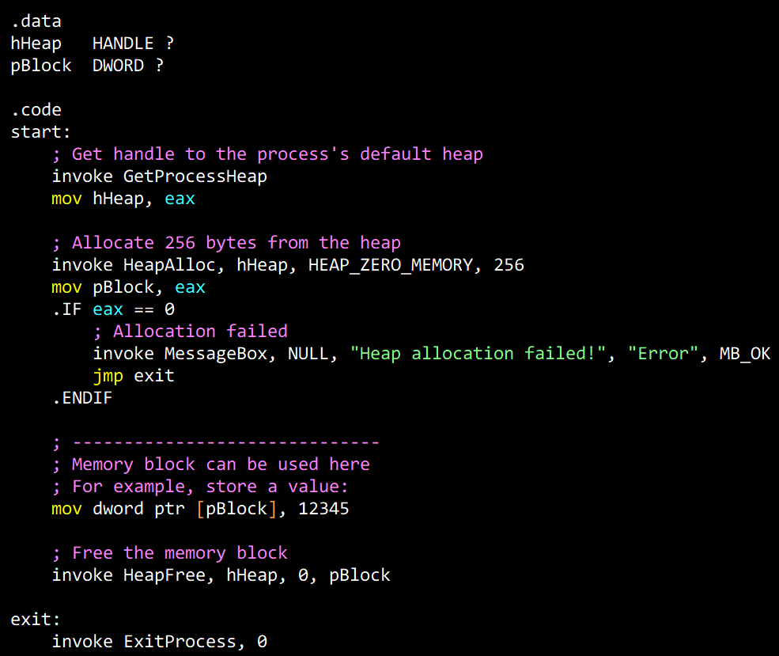

Or

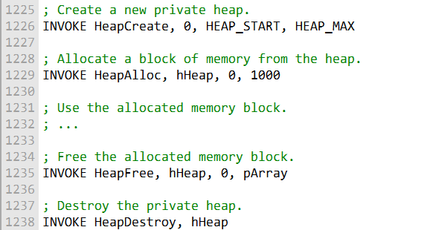

It is important to note that dynamic memory allocation should be used carefully to avoid memory leaks.

A **memory leak** occurs when a program **allocates memory** but **does not free it** when it is finished using it.

Memory leaks can lead to performance problems and eventually cause the program to crash.

Read **HeapTest1.asm** and **HeapTest2.asm**

Key Highlights from HeapTest2:

* **Custom Heap Management**: Unlike the default process heap, this creates a specific sandbox with a **400MB limit**.
* **Error Handling**: It uses the Windows API WriteWindowsMsg to translate numeric error codes into human-readable text.
* **Visual Feedback**: By printing a . for every $0.5\text{ MB}$ allocated, you can actually see the memory "filling up" in the console.
* **Status Flags**: The allocate_block procedure uses the Carry Flag as a clean way to communicate status back to the main loop without cluttering registers.

x86 MEMORY MANAGEMENT

In x86 processors, memory can be addressed in two ways: **logical addresses** and **linear addresses**.

I. Logical Address:

Think of this as a “map” to a memory location. It’s made up of two parts:

* **Segment selector** – a 16-bit value that points to a segment descriptor. The descriptor tells the CPU all about that segment of memory.
* **Offset** – a 32-bit number that tells you the exact spot inside that segment.

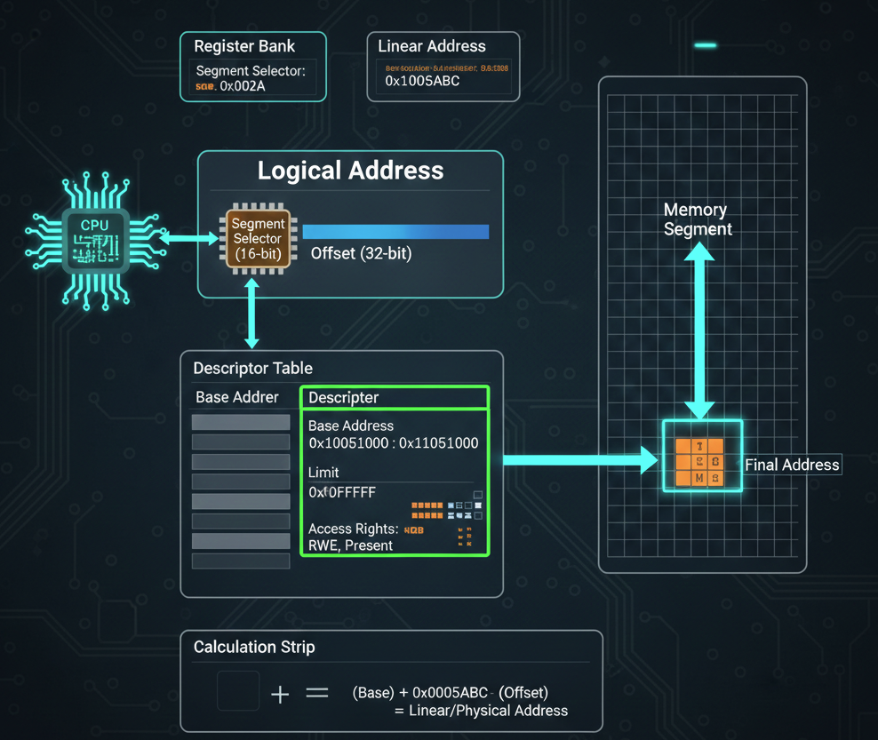

II. Linear Address:

This is the “real” memory location. It’s a 32-bit value that directly identifies a spot in memory.

You get it by adding the **segment’s base address** to the **offset**.

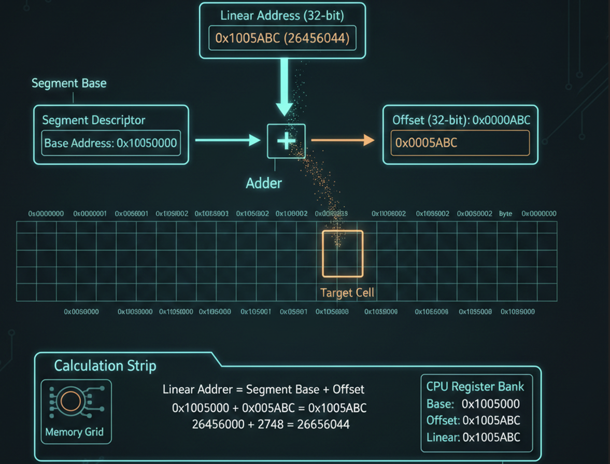

So, when the CPU goes from a logical address to a linear address, it’s essentially following a two-step translation process.

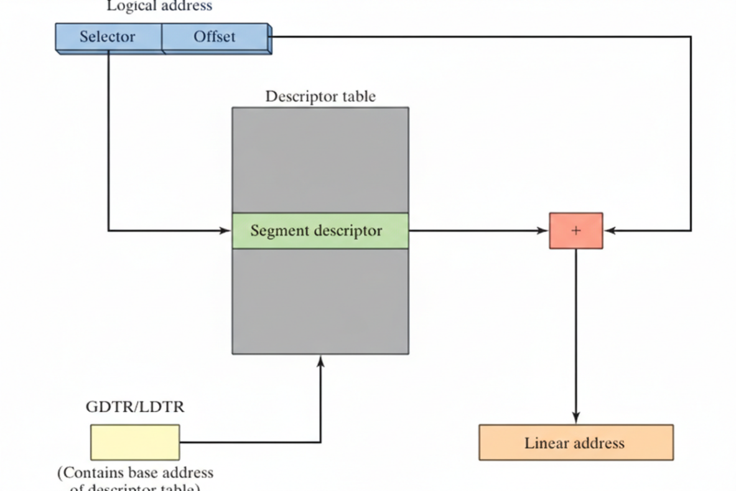

The **segment selector** acts like an index into a table of segment descriptors—either the **GDT** (Global Descriptor Table) or **LDT** (Local Descriptor Table). Once the CPU finds the right segment descriptor, it grabs the **segment’s base address**.

Next, it simply adds the **offset** from the logical address to this base address, giving the **linear address**—the CPU’s actual pointer to memory.

You can imagine it like looking up a street name in a city directory (the segment descriptor table) and then walking a certain number of steps down the street (the offset) to reach the exact house (linear address).



Once the **linear address** is calculated, the CPU can go straight to memory and access the data it needs.

**Example:**  
Imagine we have a program with a variable stored **200h** bytes into a segment.

The segment selector for this segment is **0x1000**, and the segment descriptor table shows that this segment’s **base address** is **0x100000**.

To find the variable in memory, the processor just adds the offset to the segment base address:

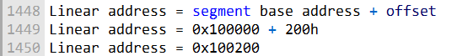

So, the CPU can now directly access the variable at **0x100200** in memory.

Paging

**Paging** is a memory management trick that helps the operating system organize memory more efficiently. It breaks **physical memory** into small, fixed-size chunks called **pages**.

Think of it like cutting a big cake into neat slices—each slice (page) is easier to manage and track than the whole cake at once.

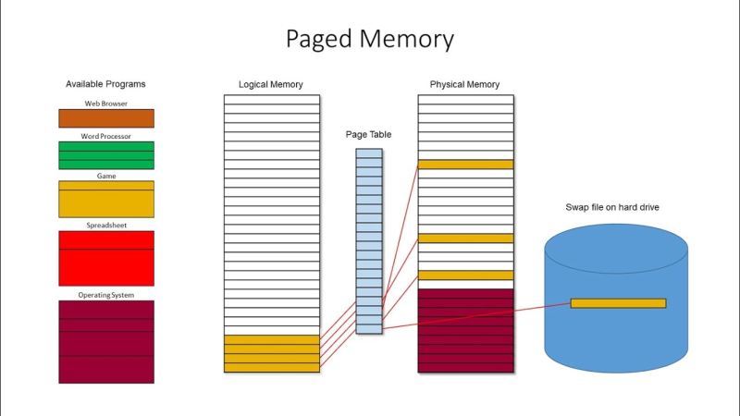

**Pages** are usually **4KB** in size, but they can also be bigger—like **2MB** or more—depending on the system.

When a program wants to access memory, the **operating system** steps in to translate the program’s **linear address** into a **physical address**. It does this using a **page table**.

The **page table** is basically a map that tells the CPU exactly which chunk of physical memory corresponds to each linear address.

You can picture it like a GPS: the linear address is your “destination name,” the page table is the “map,” and the physical address is the exact street location you need to reach.



In paging, the **linear address** is split into two parts:

* **Page table index** – the upper 20 bits, which point to the right entry in the page table.
* **Page offset** – the lower 12 bits, which tell you the exact spot within that page.

Paging gives the operating system some powerful tools, like **virtual memory** (making programs think they have more memory than physically exists) and **memory protection** (keeping programs from accidentally messing with each other’s memory).

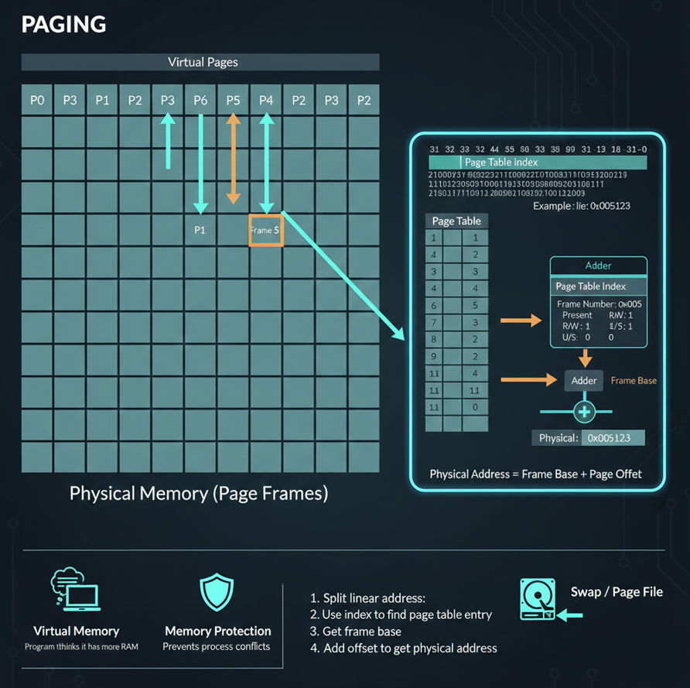

Conclusion

Memory in an x86 processor can be addressed in two ways:

* **Logical addresses** – used by programs to refer to memory.
* **Linear addresses** – used by the processor to pinpoint locations in memory.

Here’s how it all comes together:

1. The CPU translates **logical addresses** into **linear addresses** using **segment descriptors**.
2. Linear addresses can then be translated into **physical addresses** using a **page table**.

It’s like a two-step navigation system: first the CPU finds the right “street” (linear address), then it finds the exact “house” (physical address).

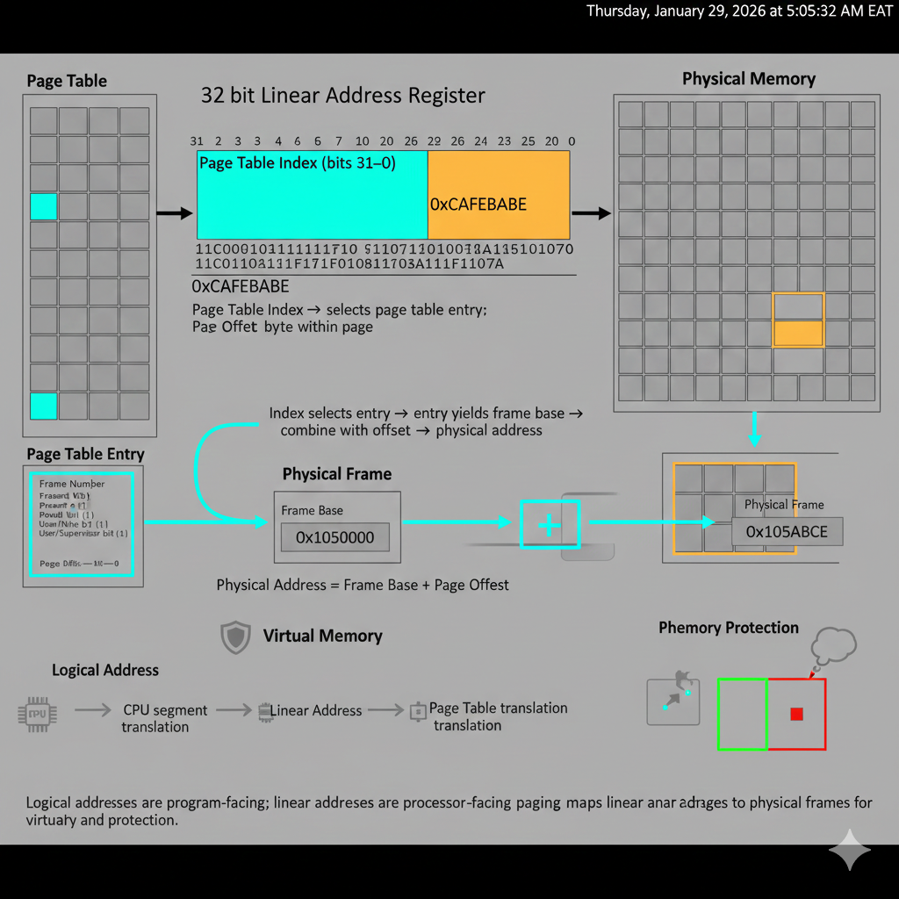

Descriptor tables

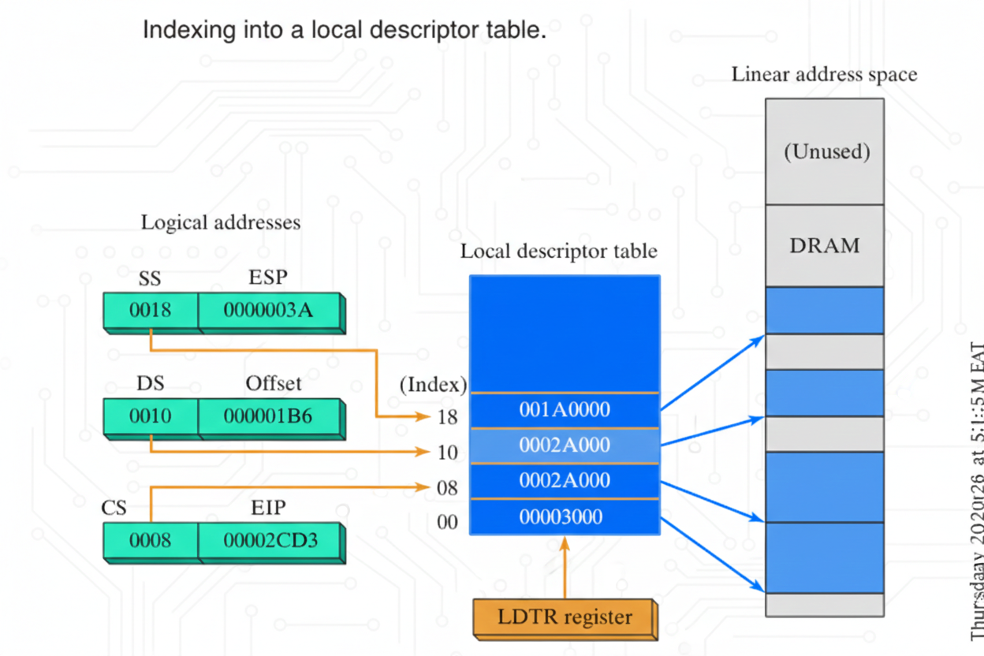

Descriptor tables are like guides that tell the CPU everything it needs to know about memory segments. A **segment** is just a chunk of memory where a program can store code or data.

There are two main types of descriptor tables:

* **Global Descriptor Table (GDT):** Contains descriptors for all the memory segments used by the system.
* **Local Descriptor Table (LDT):** Each process or task has its own LDT, containing descriptors for the segments it uses.

Each **segment descriptor** holds key information about a segment, such as its **base address**, **size**, and **access rights**. The CPU uses this info to translate **logical addresses** into **linear addresses**.

A **logical address** has two parts:

1. **Segment selector** – a 16-bit value that points to a segment descriptor in the GDT or LDT.
2. **Offset** – a 32-bit value that tells the CPU the exact location inside that segment.

To get the **linear address**, the CPU simply adds the segment’s **base address** to the **offset**. The linear address is then ready to directly access memory.

Example:  
Imagine a program with a variable located at **offset 200h** in a segment with **segment selector 0x1000**. The GDT shows that this segment has a **base address of 0x100000**.

To access the variable, the CPU calculates the linear address:

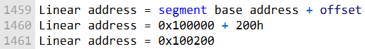

Once that’s done, the CPU can directly access the variable at **memory location 0x100200**.

Segment Descriptor Details

A **segment descriptor** is more than just a base address—it’s like a detailed profile for a segment that tells the CPU how to use it safely and correctly. Here’s what it contains:

* **Segment Limit:** This sets the maximum size of the segment. If a program tries to go beyond this limit, the CPU raises a **fault** to prevent memory errors.
* **Segment Type:** This describes what kind of data the segment holds. For example:
  + **Code segment** – stores instructions
  + **Data segment** – stores variables or other data
* **Access Rights:** These control what operations are allowed on the segment. For instance:
  + **Read-only** segments can only be read
  + **Write-only** segments can only be written to  
    The CPU uses these rules to prevent unauthorized memory access.

Other important fields in a segment descriptor include:

* **Base Address:** Where the segment starts in the linear address space
* **Privilege Level:** Indicates who can access the segment, ranging from **0 (most privileged)** to **3 (least privileged)**
* **Segment Present Flag:** Shows whether the segment is currently in memory
* **Granularity Flag:** Determines whether the segment limit is measured in **bytes** or **4KB blocks**
* **Segment Limit:** Maximum size of the segment
* **Protection Level:** Helps protect operating system data from access by applications

The CPU enforces these rules: if a program with a higher privilege level tries to access a segment with a lower privilege level (like a user program trying to touch OS data), it triggers a **processor fault**. This keeps critical system data safe from mistakes or malicious activity.

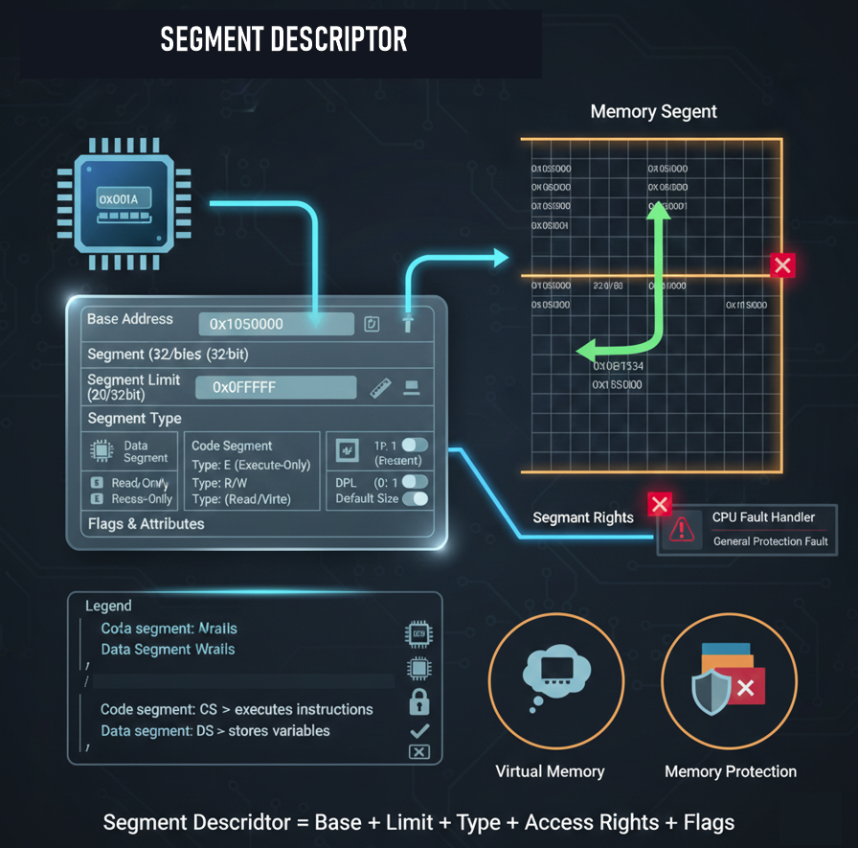

So, here’s how those fields actually work together:

* **Segment Type Field:**  
  This field defines *both* what kind of data the segment holds and what you’re allowed to do with it. For example, a **code segment** can be executed, while a **data segment** can be read from or written to.
* **Segment Present Flag:**  
  This flag tells the processor whether the segment is currently loaded in memory.
  + If the flag is **set**, the segment is present and can be accessed.
  + If it’s **not set**, the segment isn’t in memory, and any attempt to use it will fail.
* **Granularity Flag:**  
  This flag controls how the **segment limit** is measured.
  + If the flag is **set**, the limit is interpreted in **4096-byte (4KB) units**.
  + If it’s **not set**, the limit is interpreted in **bytes**.
* **Segment Limit Field:**  
  This field defines the maximum size of the segment. If a program tries to access memory beyond this limit, the processor immediately raises a **fault** to stop the access.

Overall, **segment descriptors** play a critical role in x86 memory management. They allow the processor to translate **logical addresses** into **linear addresses**, while also enforcing protection rules so programs can’t access memory they’re not supposed to.

[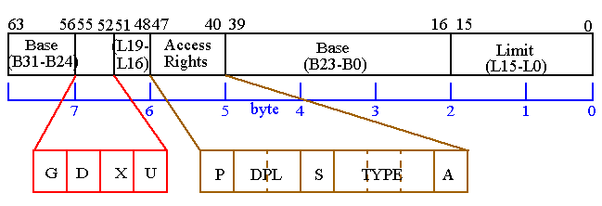](https://ece-research.unm.edu/jimp/310/slides/micro_arch2-2.gif)

Described segment descriptor:

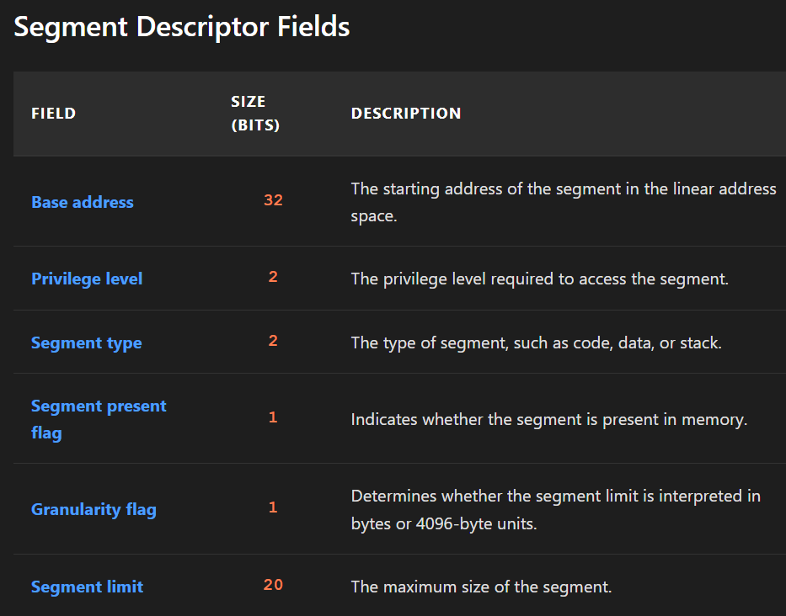

The **segment descriptor diagram** also highlights a few important details:

* The **Global Descriptor Table (GDT)** is located at **address 0x00000000**.
* The **segment selector** is a **16-bit value** that points to a specific segment descriptor inside the GDT.
* The **linear address** is a **32-bit value** that identifies an exact location in the linear address space.

Here’s how the processor puts it all together:  
The CPU uses the **segment selector** to index into the **GDT** and fetch the correct **segment descriptor**. It then uses the information in that descriptor—especially the **base address**—to calculate the **linear address** of the requested memory location.

In short, the diagram shows how the processor moves step by step from a logical reference to a real, usable memory address.

**NB(FORMER SUBTOPIC):**

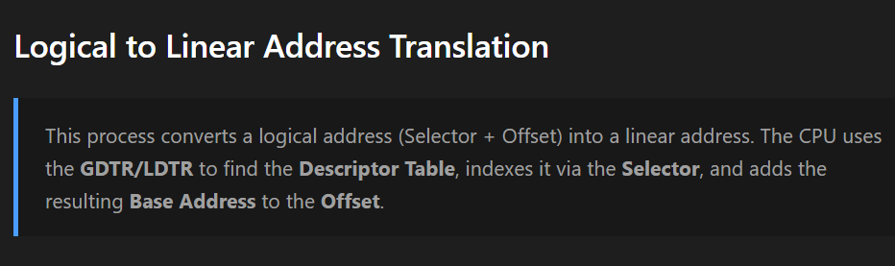

Page translation

**Page translation** is the process the x86 processor uses to convert a **linear address** into a **physical address** when paging is enabled.

A **linear address** is a 32-bit value that identifies a location in the linear address space. A **physical address** is also a 32-bit value, but it points to an actual location in physical memory.

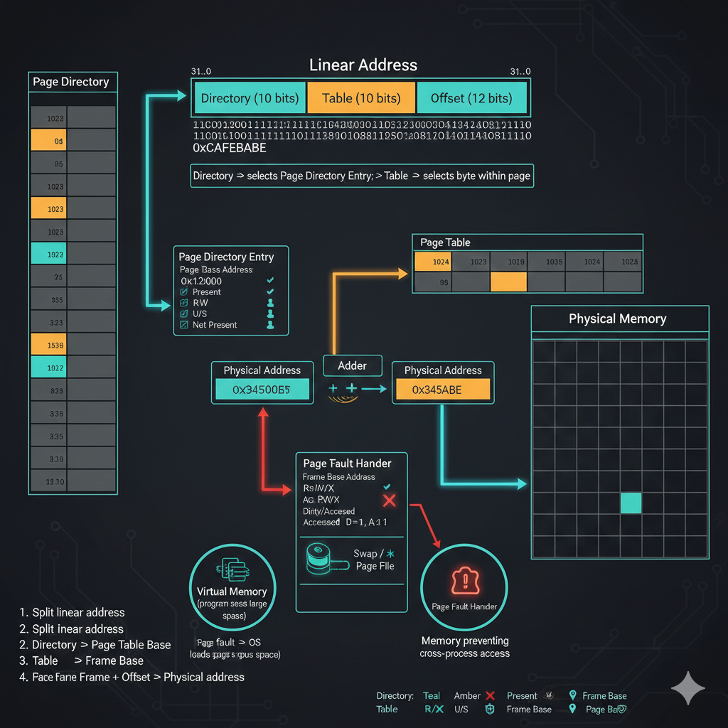

Paging lets the operating system divide physical memory into fixed-size blocks called **pages**, which are typically **4KB**.

To keep track of where everything lives, the OS uses a **page table** to map linear (virtual) addresses to physical addresses.

The **page table** is a data structure with one entry for each page in the virtual address space. Each entry stores:

* The **physical address** of the page
* The page’s **access rights**

When the processor needs to read or write memory, it first looks up the corresponding **page table entry** for the given linear address:

* If the entry is **valid**, the processor uses the physical address and accesses memory normally.
* If the entry is **not valid**, the processor raises a **page fault**, allowing the operating system to step in and handle the situation.

Steps in Page Translation

Let’s walk through what the **page table diagram** is showing:

1. The **linear address** refers to a location in the linear address space.
2. The **10-bit directory field** in the linear address is used as an index into the **page directory**. The selected **page-directory entry** contains the base address of a page table.
3. The **10-bit table field** is then used as an index into that page table. The corresponding **page-table entry** provides the base address of a page in physical memory.
4. Finally, the **12-bit offset** is added to the page’s base address, producing the **exact physical address** of the data being accessed.

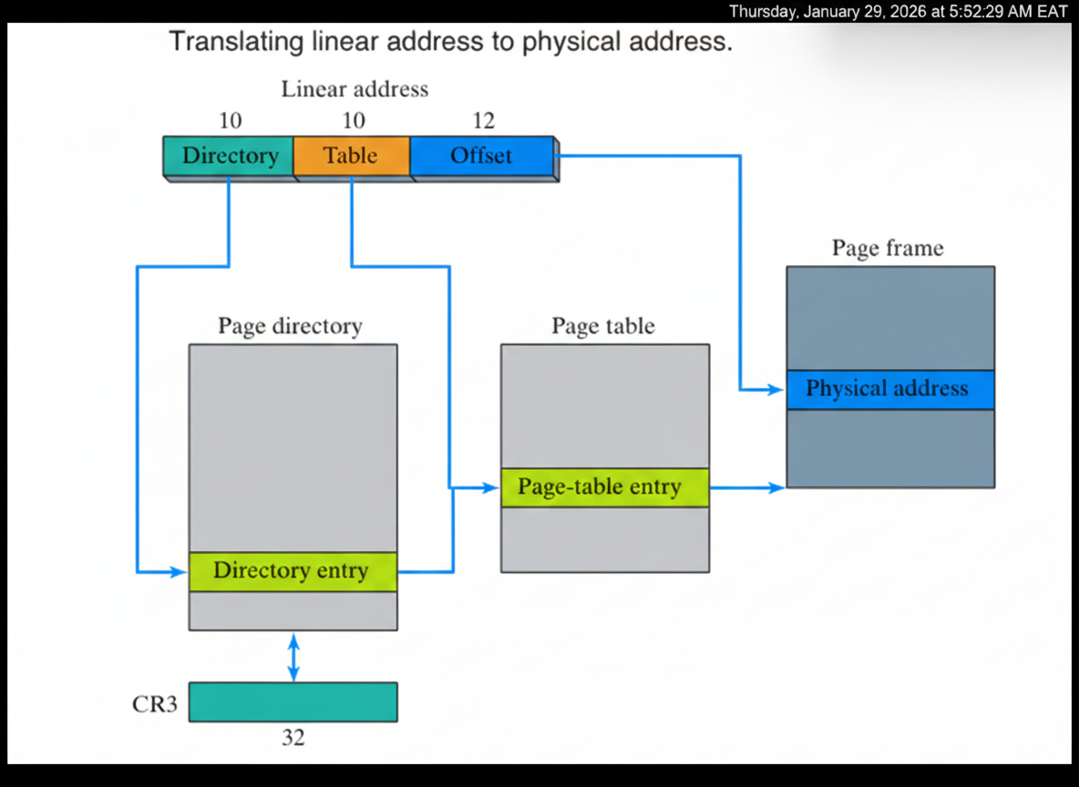

Linear-to-Physical Address Translation (Paging)

When paging is enabled, the processor follows a clear set of steps to translate a **linear address** into a **physical address**.

First, the processor splits the **32-bit linear address** into three fields:

* **Directory field** – the upper **10 bits** of the linear address
* **Table field** – the middle **10 bits** of the linear address
* **Offset field** – the lower **12 bits** of the linear address

Next, the processor uses these fields step by step:

1. The **directory field** is used to index into the **page directory**, which contains **1024 entries**, each **4 bytes** in size.
   * Each page-directory entry points to a **page table**.
2. The **table field** is then used to index into the selected **page table**.
   * The page table also has **1024 entries**, each **4 bytes** long.
   * Each page-table entry points to a **physical page frame** in memory.
3. Finally, the processor adds the **offset field** to the base address of the physical page frame.
   * This produces the **exact physical address** of the requested memory location.

Example

Suppose the processor is given the linear address:

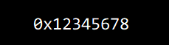

The processor splits it like this:

* **Directory field (upper 10 bits)**
* **Table field (next 10 bits)**
* **Offset field (lower 12 bits)**

Using these fields:

1. The **directory field** is used to index the **page directory**, which provides the address of the correct page table.
2. The **table field** indexes into that page table, yielding the base address of the physical page frame.
3. The **offset** is added to that base address, producing the final **physical address**.

At the end of this process, the processor knows exactly where the data lives in physical memory.

Conclusion

The operating system can choose how to manage page directories:

* One **shared page directory** for all tasks
* One **page directory per task**
* Or a **hybrid approach**

Page translation is a core part of memory management in x86 processors. It allows the operating system to divide physical memory into pages, map **virtual (linear) addresses** to **physical addresses**, and enforce **memory protection**.

This is what makes features like **virtual memory** possible—while also preventing programs from accessing memory they shouldn’t.

Windows Virtual Machine Manager (VMM)

The **Windows Virtual Machine Manager (VMM)** is the 32-bit, protected-mode operating system at the heart of Windows. Its job is to **create, run, monitor, and shut down virtual machines**, while also handling critical system tasks like **memory management, process scheduling, interrupts, and exceptions**.



VMM operates using a **single 32-bit flat address space** at **privilege level 0** (the highest level). This means the VMM itself, all virtual machines, and any virtual devices all live in the **same address space**.

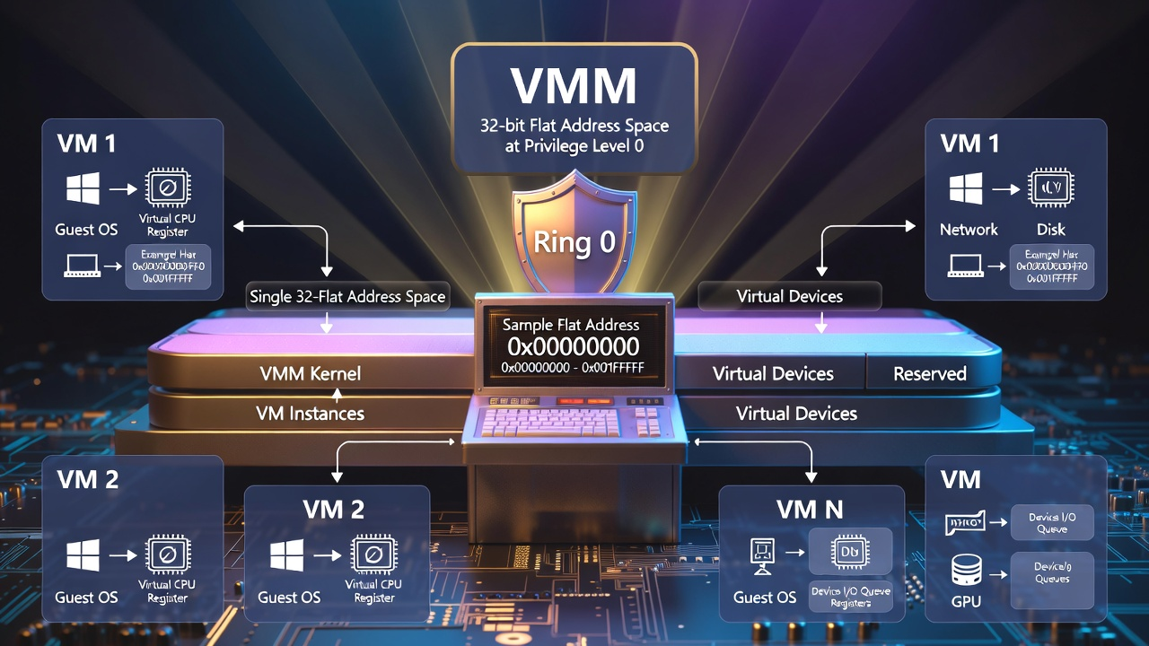

For each virtual machine, the VMM creates **two Global Descriptor Table (GDT) entries**:

* one for **code**
* one for **data**

These segments are fixed at **linear address 0**, keeping the memory model simple and consistent.

VMM also supports **multithreaded, preemptive multitasking**, allowing multiple applications to run at the same time by sharing CPU time across the virtual machines they run in.

How VMM Handles Memory Management

VMM manages memory using **paging**. Paging divides physical memory into fixed-size blocks called **pages**, which are typically **4KB** in size.

Each virtual machine gets its **own page table**, which maps that machine’s **virtual addresses** to **physical memory pages**.

Here’s what happens when a virtual machine accesses memory:

1. The processor checks the **page table entry** for the requested virtual address.
2. If the entry is **valid**, the processor accesses the corresponding physical memory location.
3. If the entry is **not valid**, the processor raises a **page fault**.

When a page fault occurs, the **VMM steps in**:

* If the virtual address is valid, VMM loads the required physical page into memory and updates the page table.
* If the virtual address is invalid, VMM raises an **exception**.

Benefits of Using VMM

Using VMM comes with several important advantages:

* **Isolation:** Each virtual machine is separated from the others, so a failure in one VM doesn’t crash the rest.
* **Security:** VMM can enforce security features like access control and encryption.
* **Performance:** Applications can run more efficiently by being separated into different virtual machines.
* **Flexibility:** VMM can manage many types of virtual machines, including servers, desktops, and testing environments.

**Windows Virtual Machine Manager** is a powerful foundation for virtualization.

It makes it possible to safely and efficiently create, run, and manage virtual machines—while delivering strong isolation, security, performance, and flexibility.

Windows:

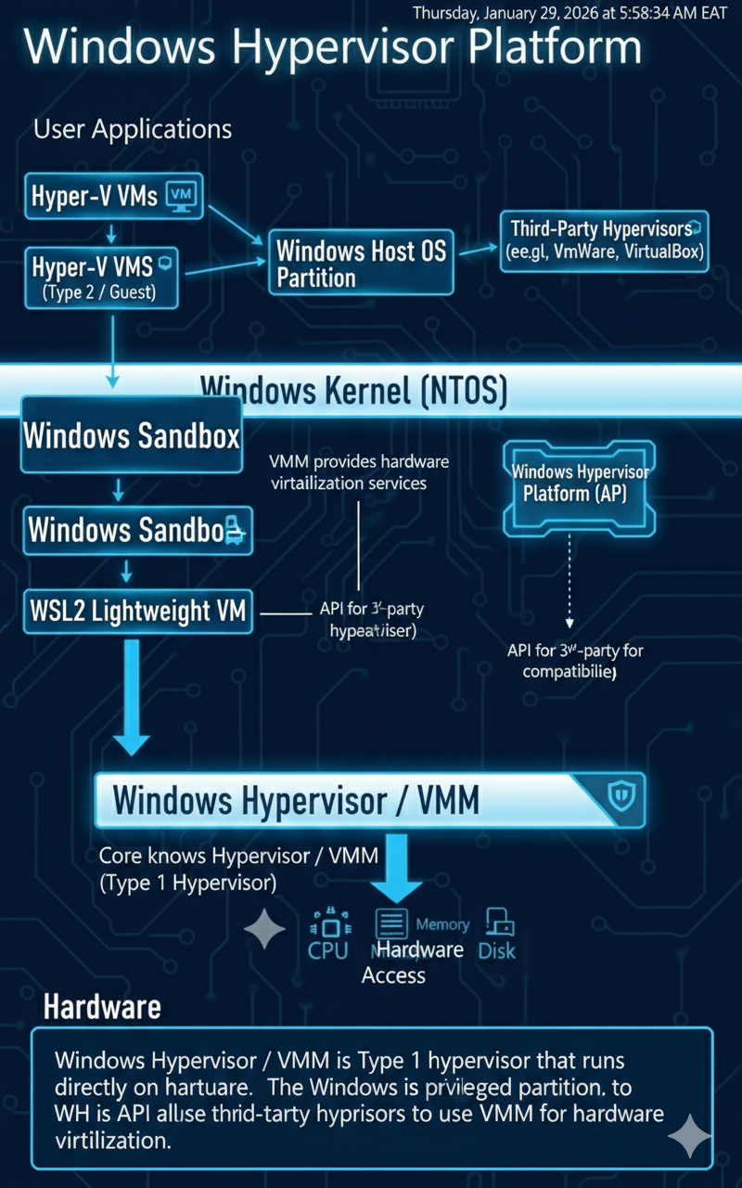

These images aren’t perfect, they are here to give you an idea.

Linux:

